Oblique Cross Section

Definition
# Source: AI Source: Provided by: [Data Path: Persons Table -> ID Column: 1, Name_En Column: Motasem Essam] -> From: [ChatGPT] on [7/25/2026]
An Oblique Cross Section is a two-dimensional geometric figure formed when a three-dimensional solid is intersected by an inclined plane that is neither parallel nor perpendicular to the solid's horizontal base plane.
The cutting plane passes through the solid at an angle, producing a cross-sectional shape determined by the solid's geometry, the plane's inclination, and its position.
An oblique cross-section may be polygonal, circular, elliptical, or another curved or irregular shape.
The resulting shape depends on:
- The geometric shape of the solid.
- The inclination angle of the cutting plane.
- The position of the cutting plane.
- The number and type of solid faces or surfaces intersected by the plane.
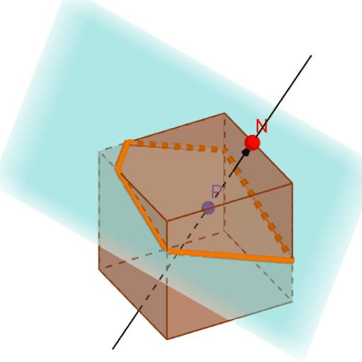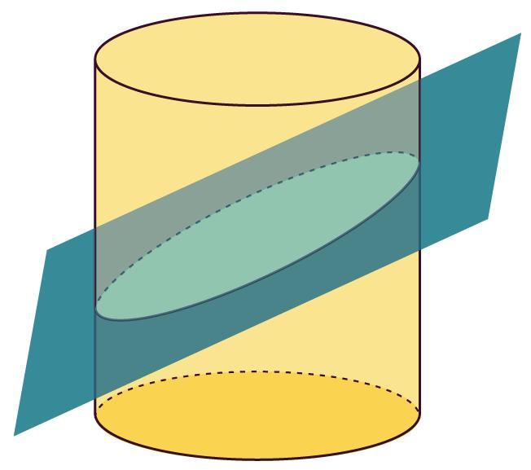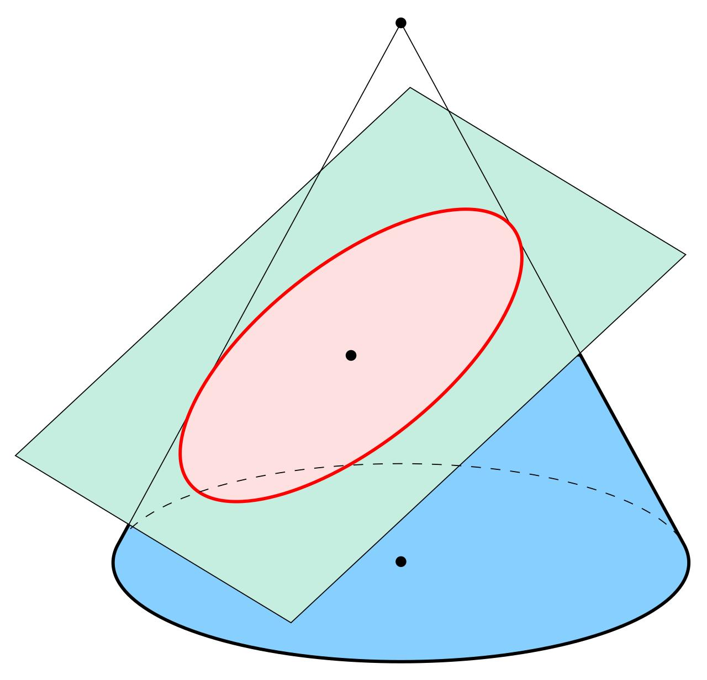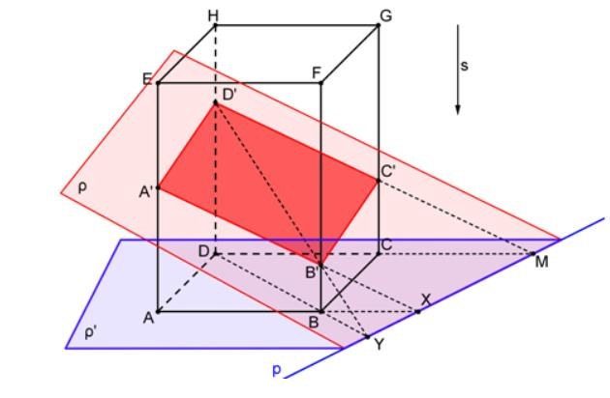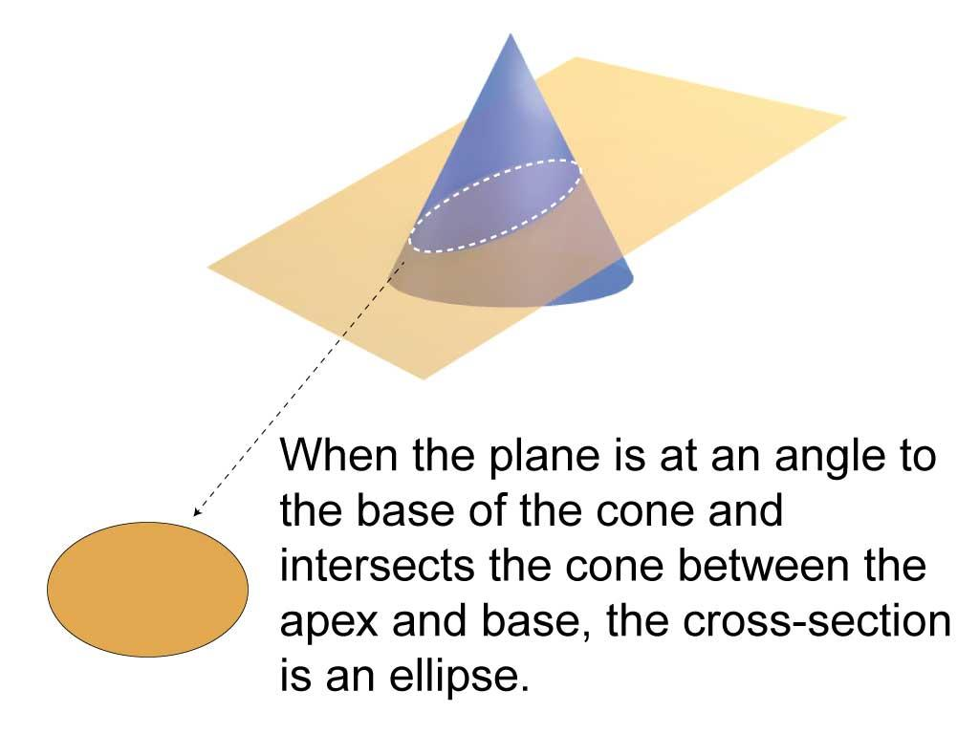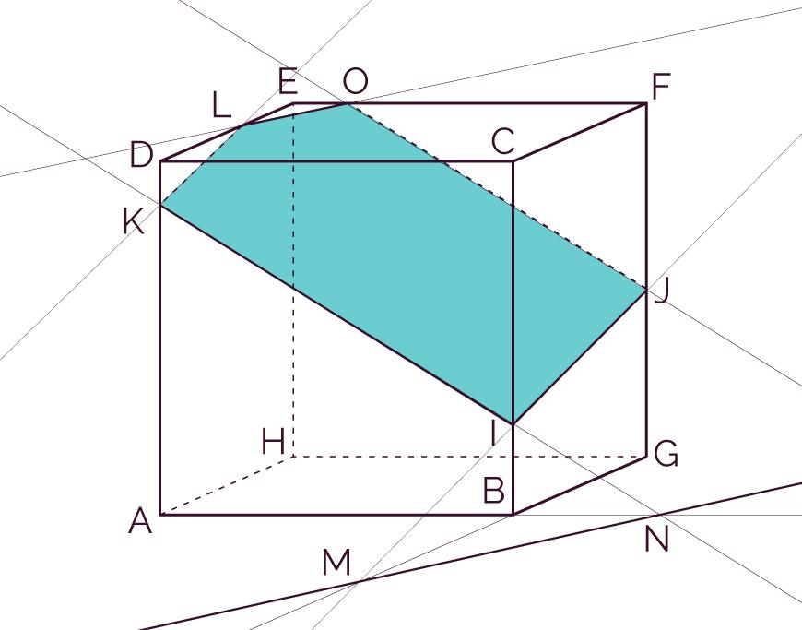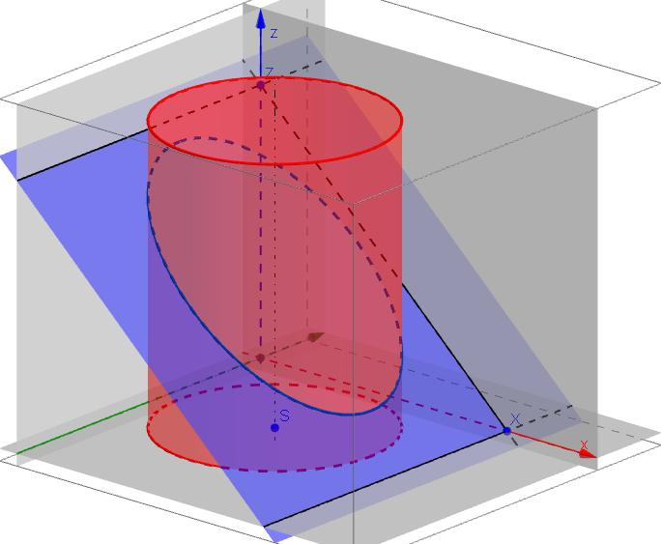

Geometric Structure
# Source: AI Source: Provided by: [Data Path: Persons Table -> ID Column: 1, Name_En Column: Motasem Essam] -> From: [ChatGPT] on [7/25/2026]
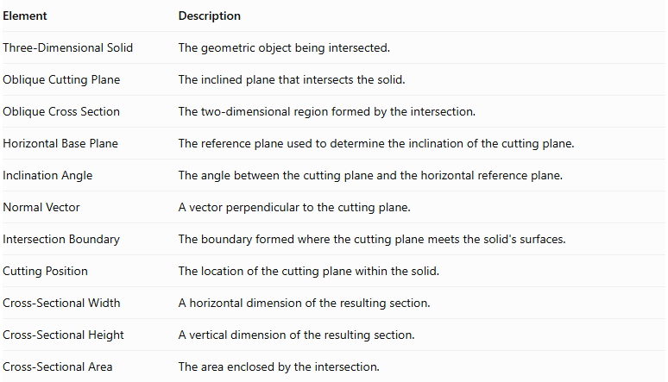
Element | Description
Three-Dimensional Solid | The geometric object being intersected.
Oblique Cutting Plane | The inclined plane that intersects the solid.
Oblique Cross Section | The two-dimensional region formed by the intersection.
Horizontal Base Plane | The reference plane used to determine the inclination of the cutting plane.
Inclination Angle | The angle between the cutting plane and the horizontal reference plane.
Normal Vector | A vector perpendicular to the cutting plane.
Intersection Boundary | The boundary formed where the cutting plane meets the solid's surfaces.
Cutting Position | The location of the cutting plane within the solid.
Cross-Sectional Width | A horizontal dimension of the resulting section.
Cross-Sectional Height | A vertical dimension of the resulting section.
Cross-Sectional Area | The area enclosed by the intersection.

Main Characteristics
# Source: AI Source: Provided by: [Data Path: Persons Table -> ID Column: 1, Name_En Column: Motasem Essam] -> From: [ChatGPT] on [7/25/2026]
- The cutting plane is inclined relative to the horizontal base plane.
- It is neither parallel nor perpendicular to the horizontal base plane.
- The resulting cross-section is two-dimensional.
- Its shape depends on the solid and the cutting plane's orientation.
- Changing the inclination angle can change the shape and dimensions of the cross-section.
- Changing the cutting position can produce a different cross-section even when the inclination remains unchanged.
- The plane may intersect several faces of a polyhedron or a curved surface.
- An oblique cross-section may be symmetrical or asymmetrical.

Types of Oblique Cross Sections According to Geometric Shape

Triangular Oblique Cross Section
# Source: AI Source: Provided by: [Data Path: Persons Table -> ID Column: 1, Name_En Column: Motasem Essam] -> From: [ChatGPT] on [7/25/2026]
A Triangular Oblique Cross Section is formed when an inclined plane intersects a solid in a region bounded by three straight line segments.
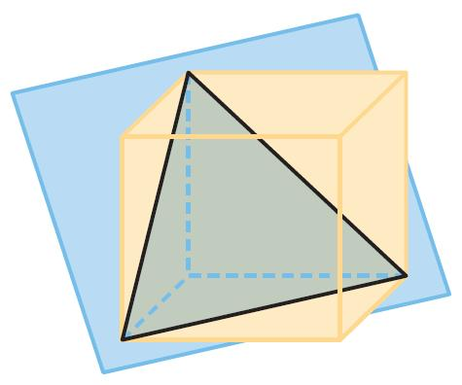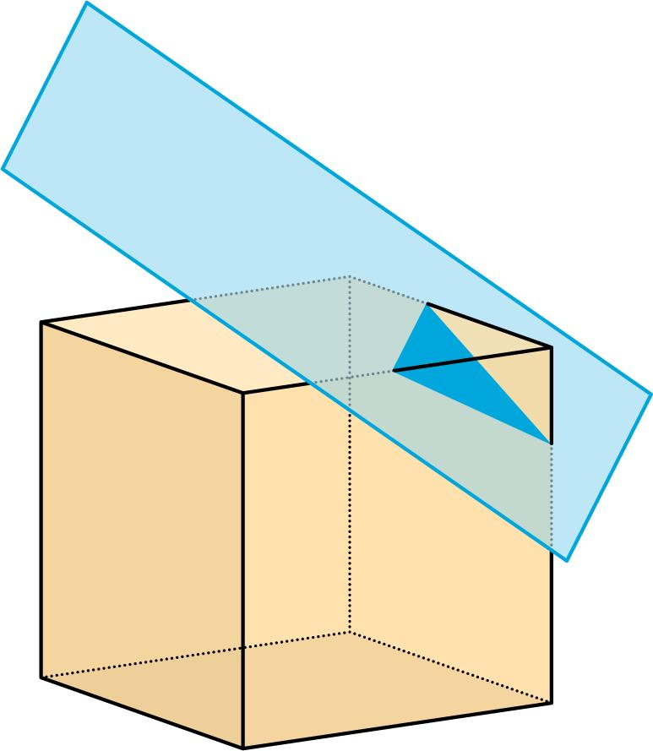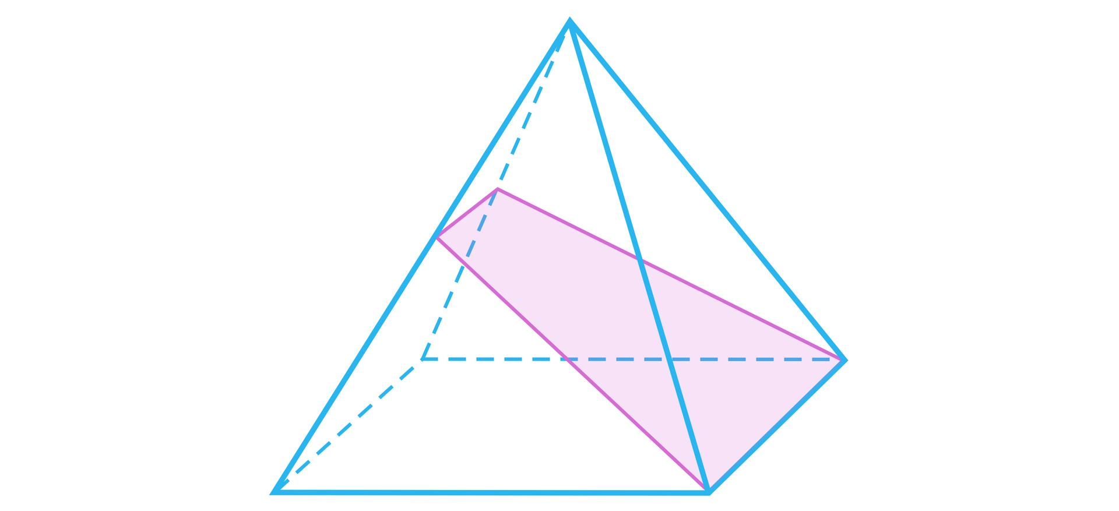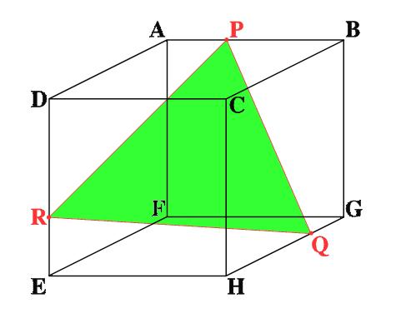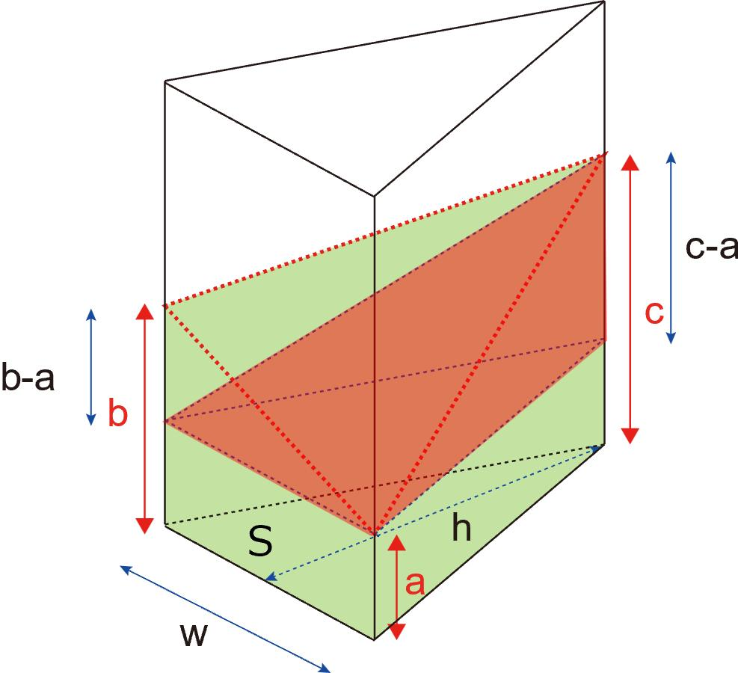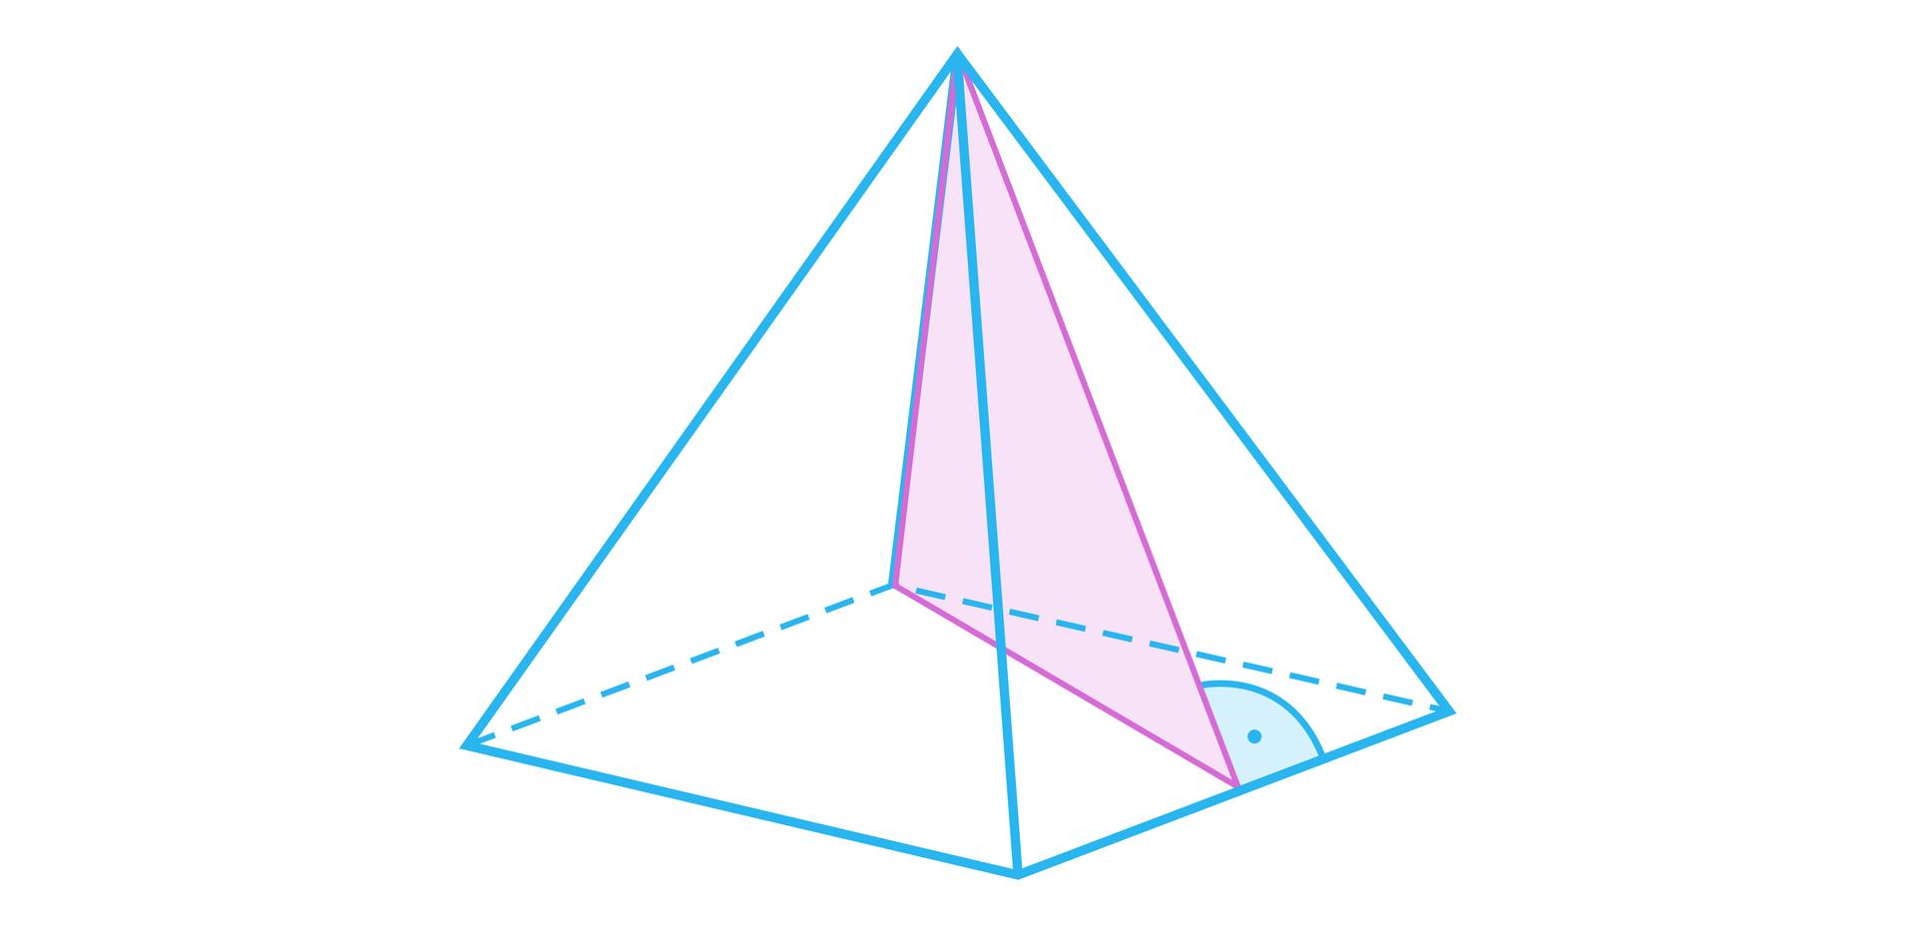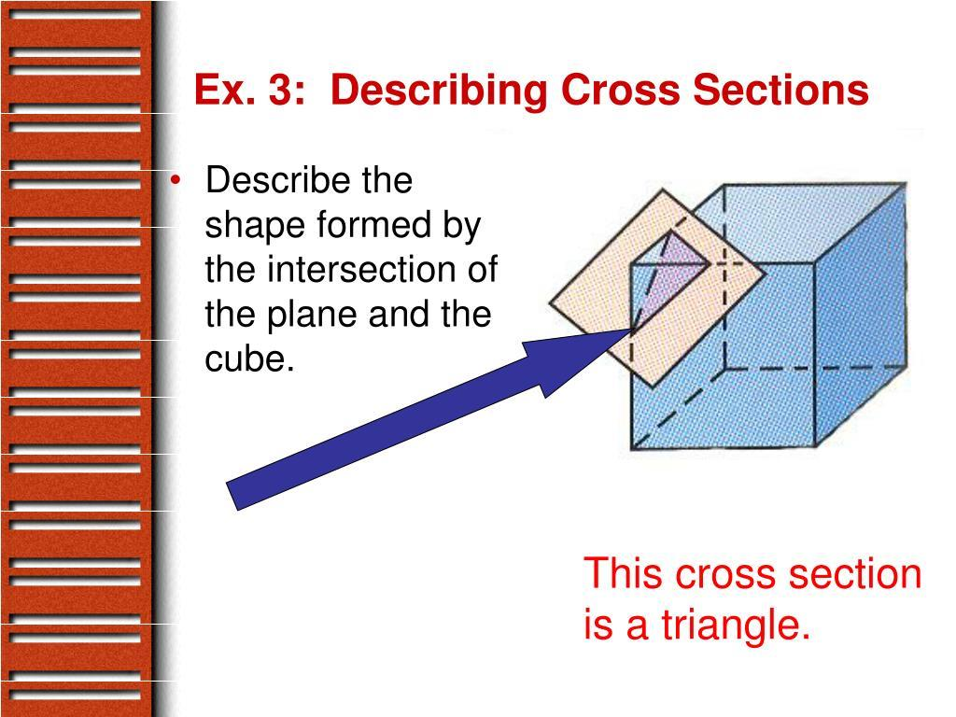
Examples:
- Cube intersected near one corner.
- Triangular or polygonal pyramid intersected by a suitable inclined plane.
- Triangular prism intersected by an inclined plane that meets three appropriate faces.
The resulting triangle may be equilateral, isosceles, or scalene.

Quadrilateral Oblique Cross Section
# Source: AI Source: Provided by: [Data Path: Persons Table -> ID Column: 1, Name_En Column: Motasem Essam] -> From: [ChatGPT] on [7/25/2026]
A Quadrilateral Oblique Cross Section is formed when an inclined plane intersects a solid in a region bounded by four straight line segments.
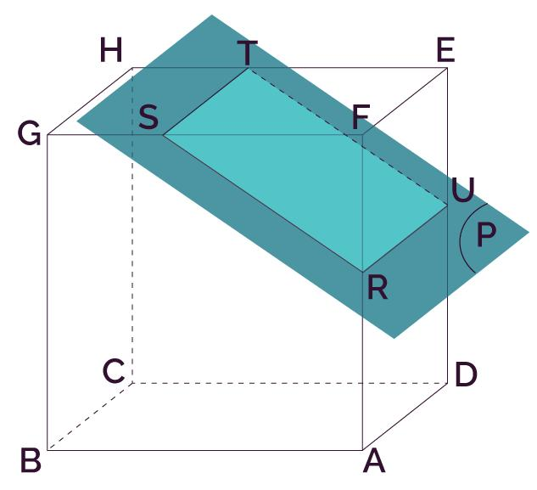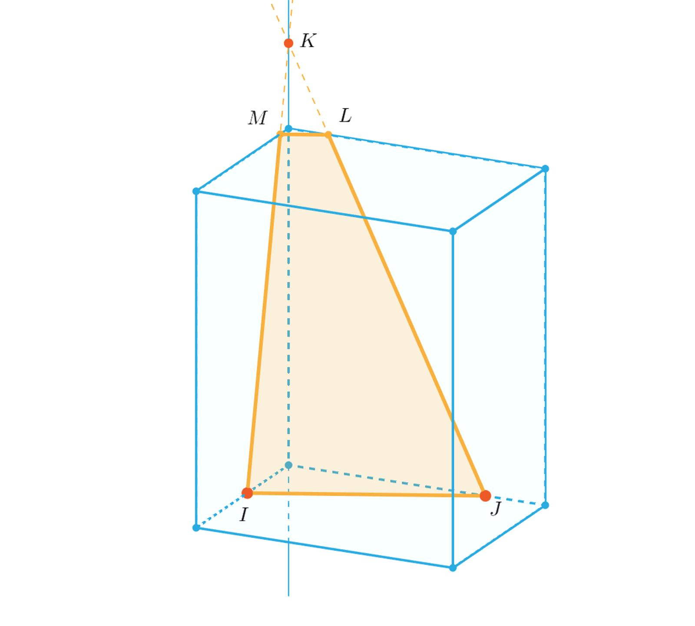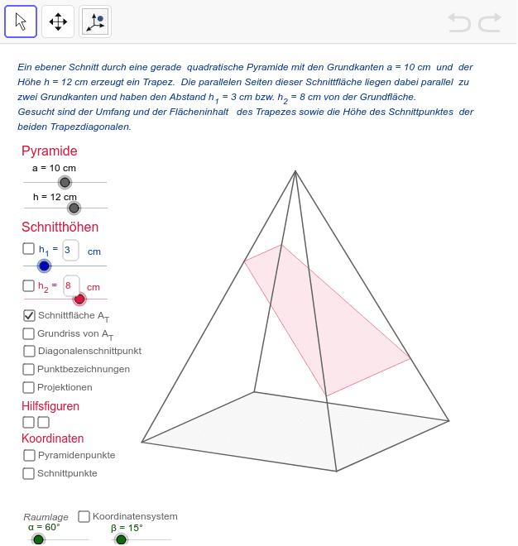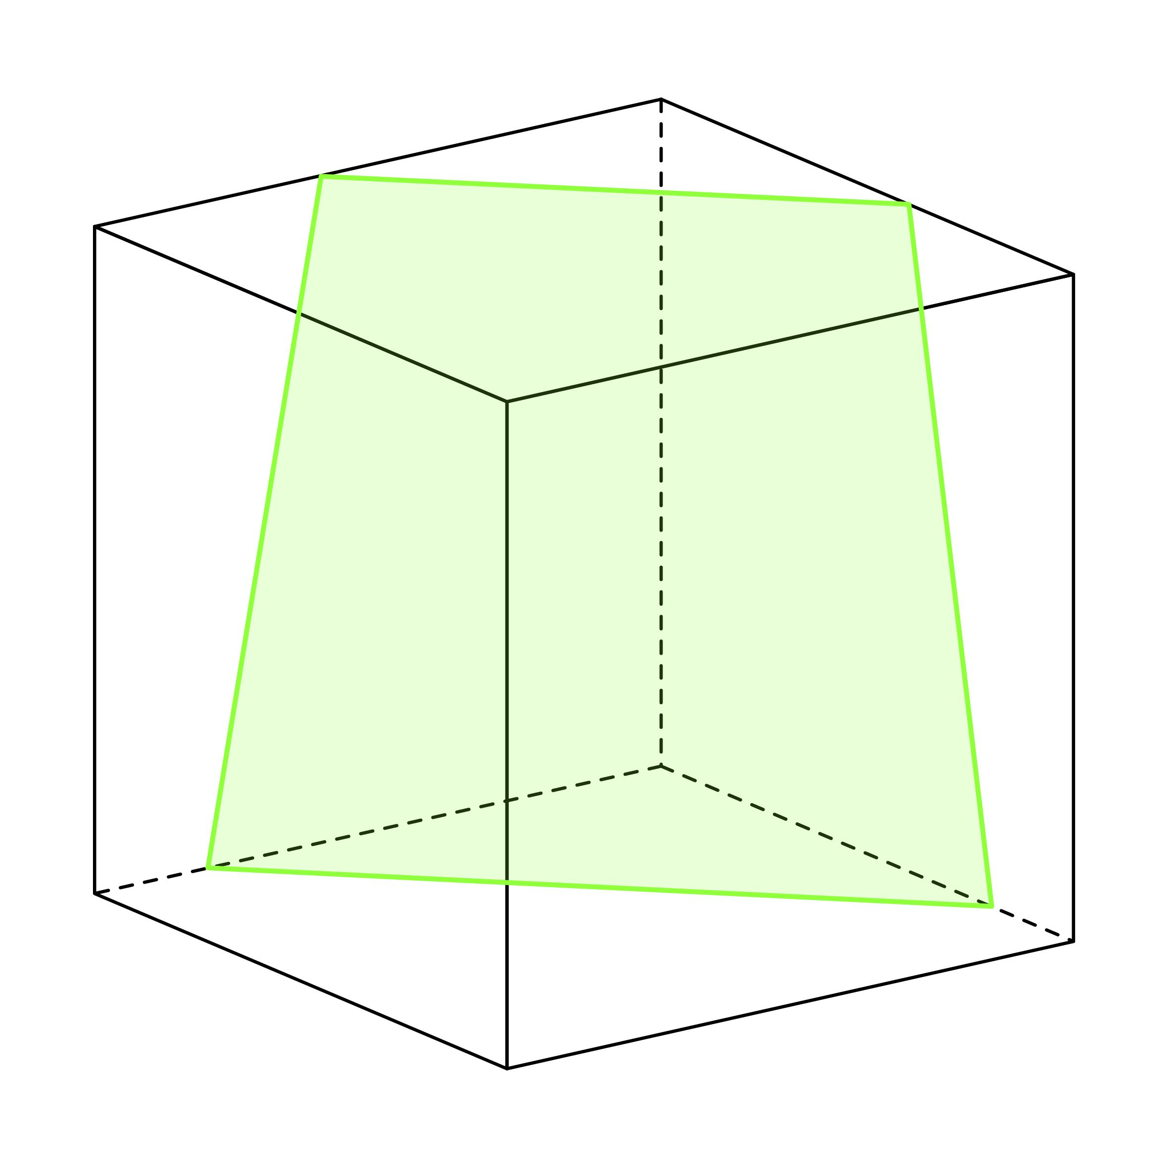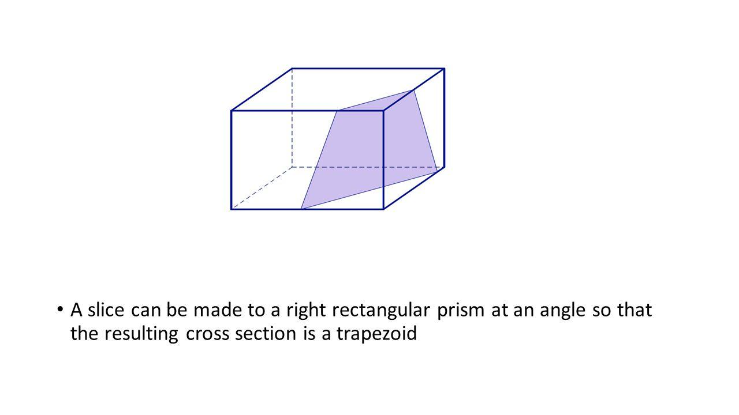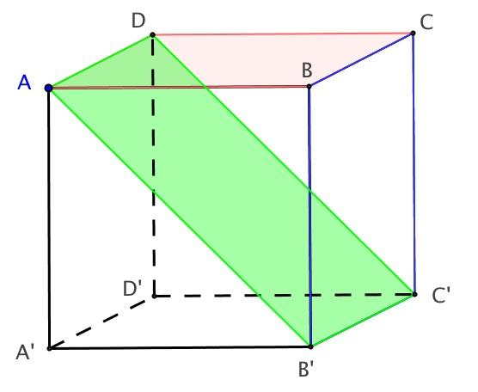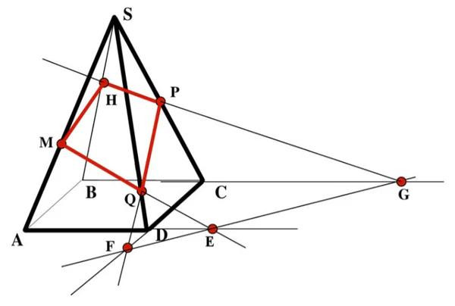
Possible shapes include:
- Rectangle.
- Square.
- Parallelogram.
- Rhombus.
- Trapezoid.
- Irregular Quadrilateral.
The exact shape depends on the cutting plane's position and orientation.

Pentagonal Oblique Cross Section
# Source: AI Source: Provided by: [Data Path: Persons Table -> ID Column: 1, Name_En Column: Motasem Essam] -> From: [ChatGPT] on [7/25/2026]
A Pentagonal Oblique Cross Section is formed when an inclined plane intersects a solid in a region bounded by five straight line segments.
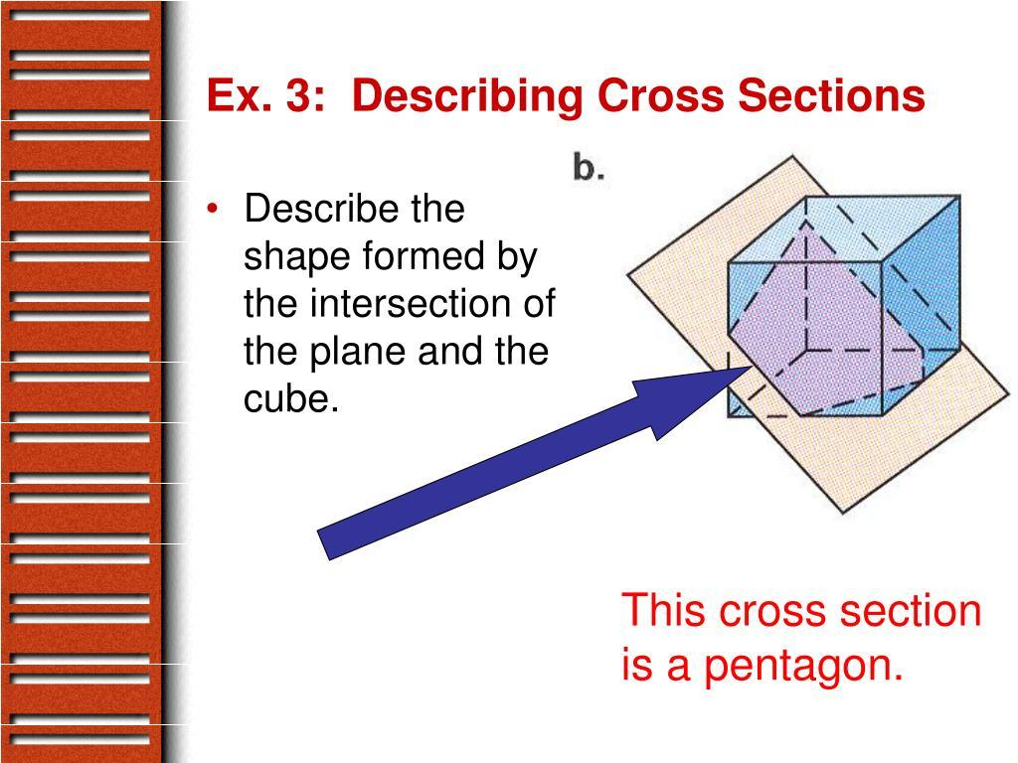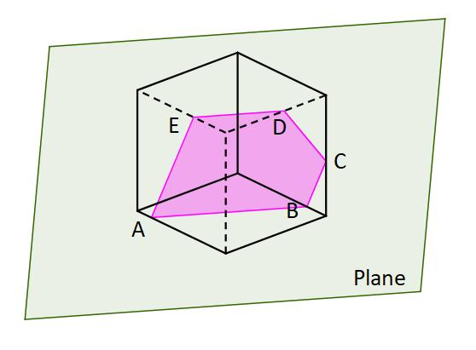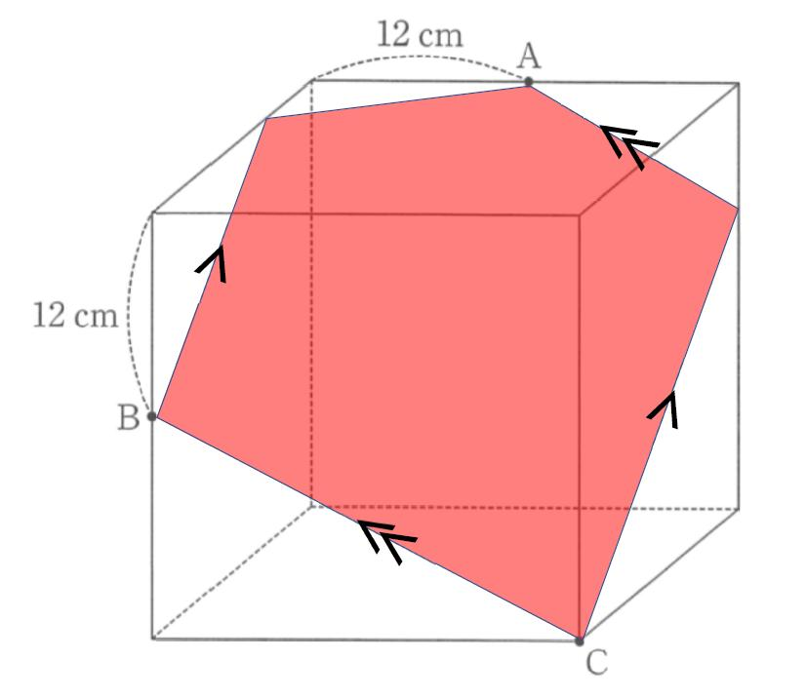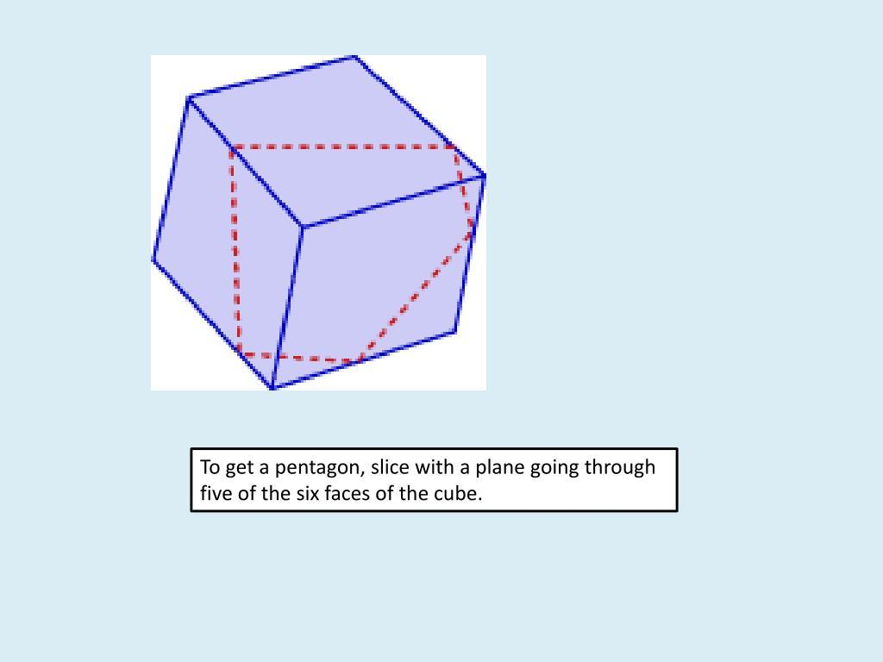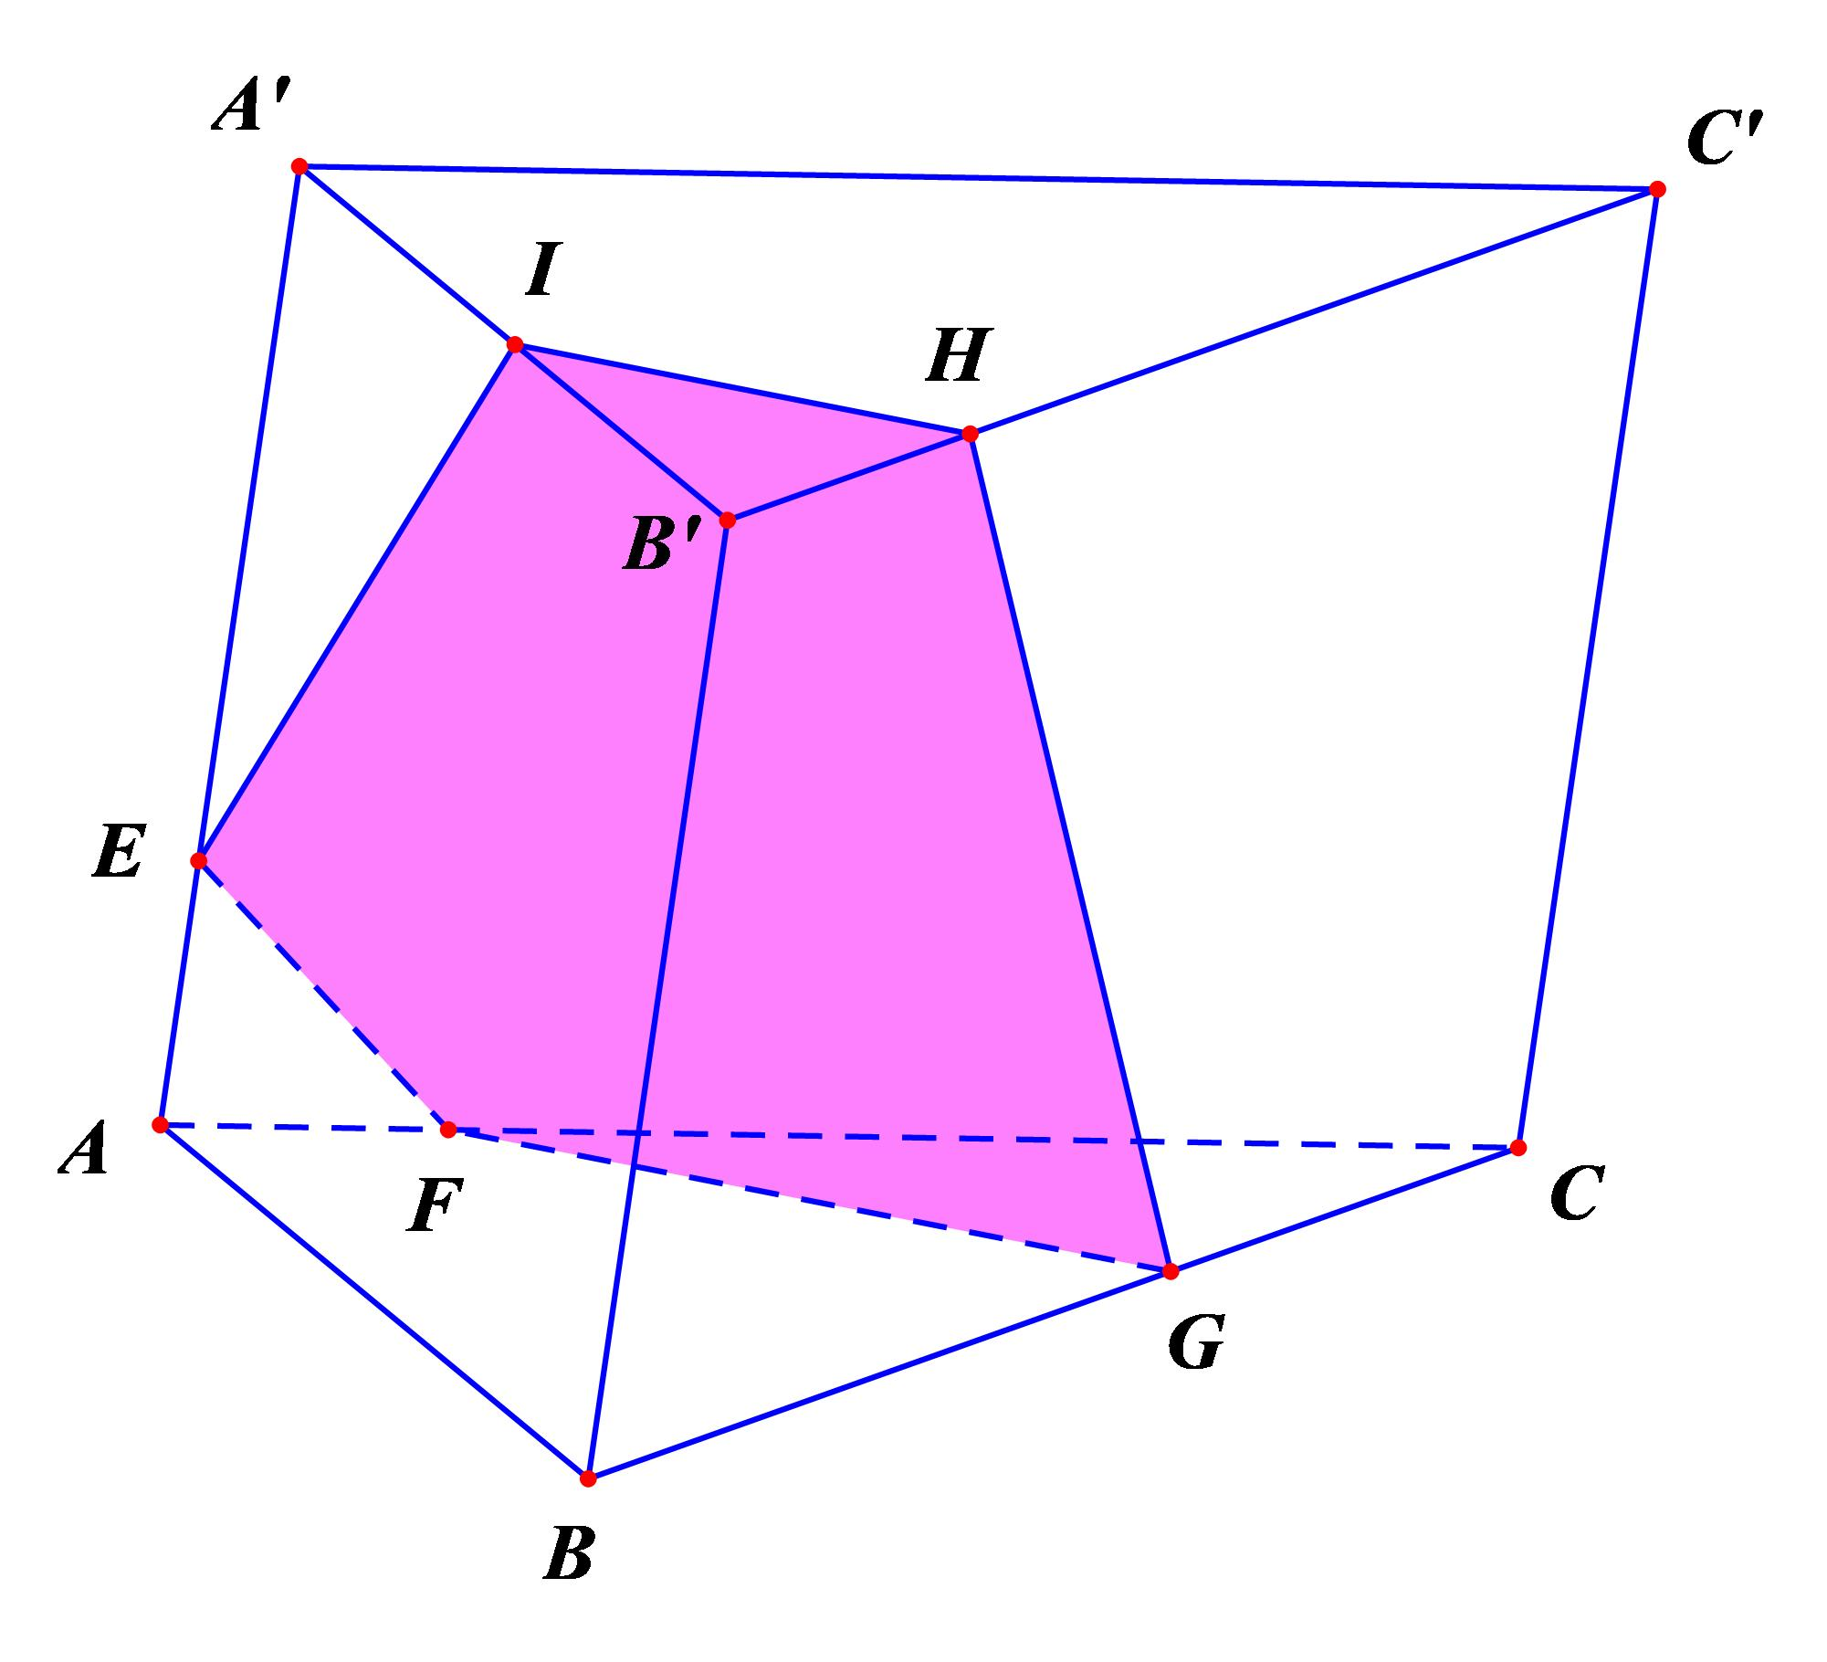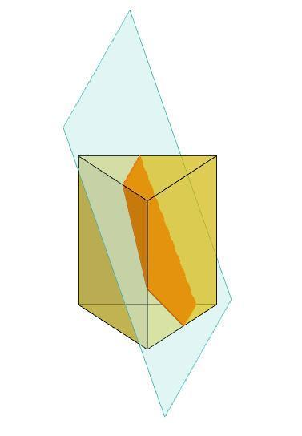
Examples:
- Cube intersected by a plane passing through five of its faces.
- Prism or other polyhedron intersected by a suitable inclined plane.

Hexagonal Oblique Cross Section
# Source: AI Source: Provided by: [Data Path: Persons Table -> ID Column: 1, Name_En Column: Motasem Essam] -> From: [ChatGPT] on [7/25/2026]
A Hexagonal Oblique Cross Section is formed when an inclined plane intersects a solid in a region bounded by six straight line segments.
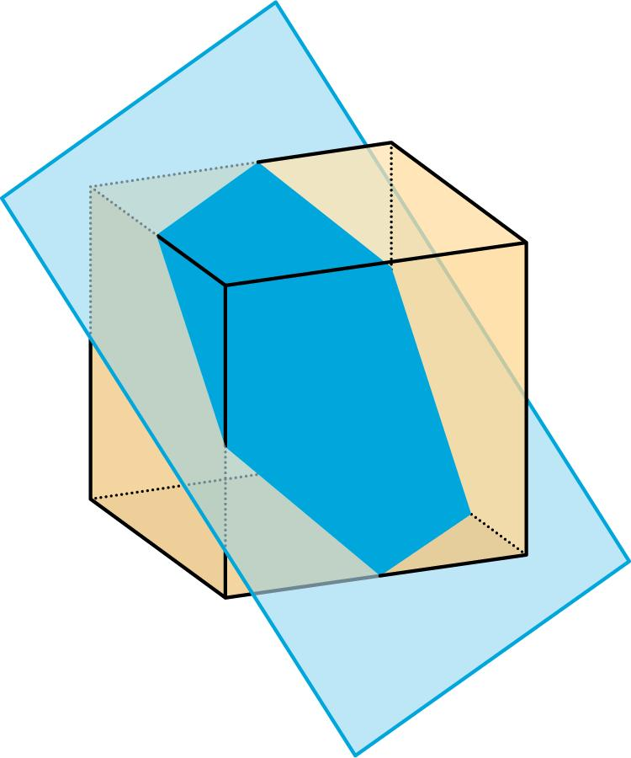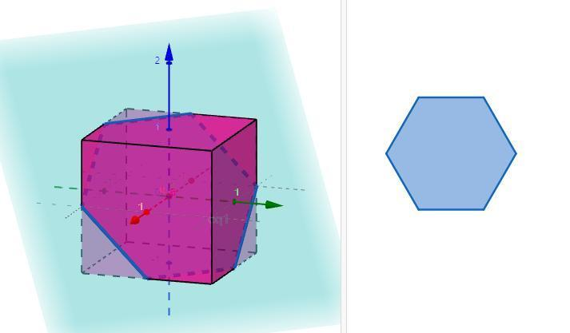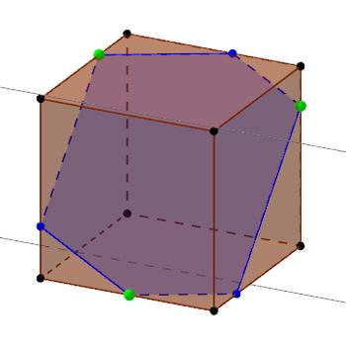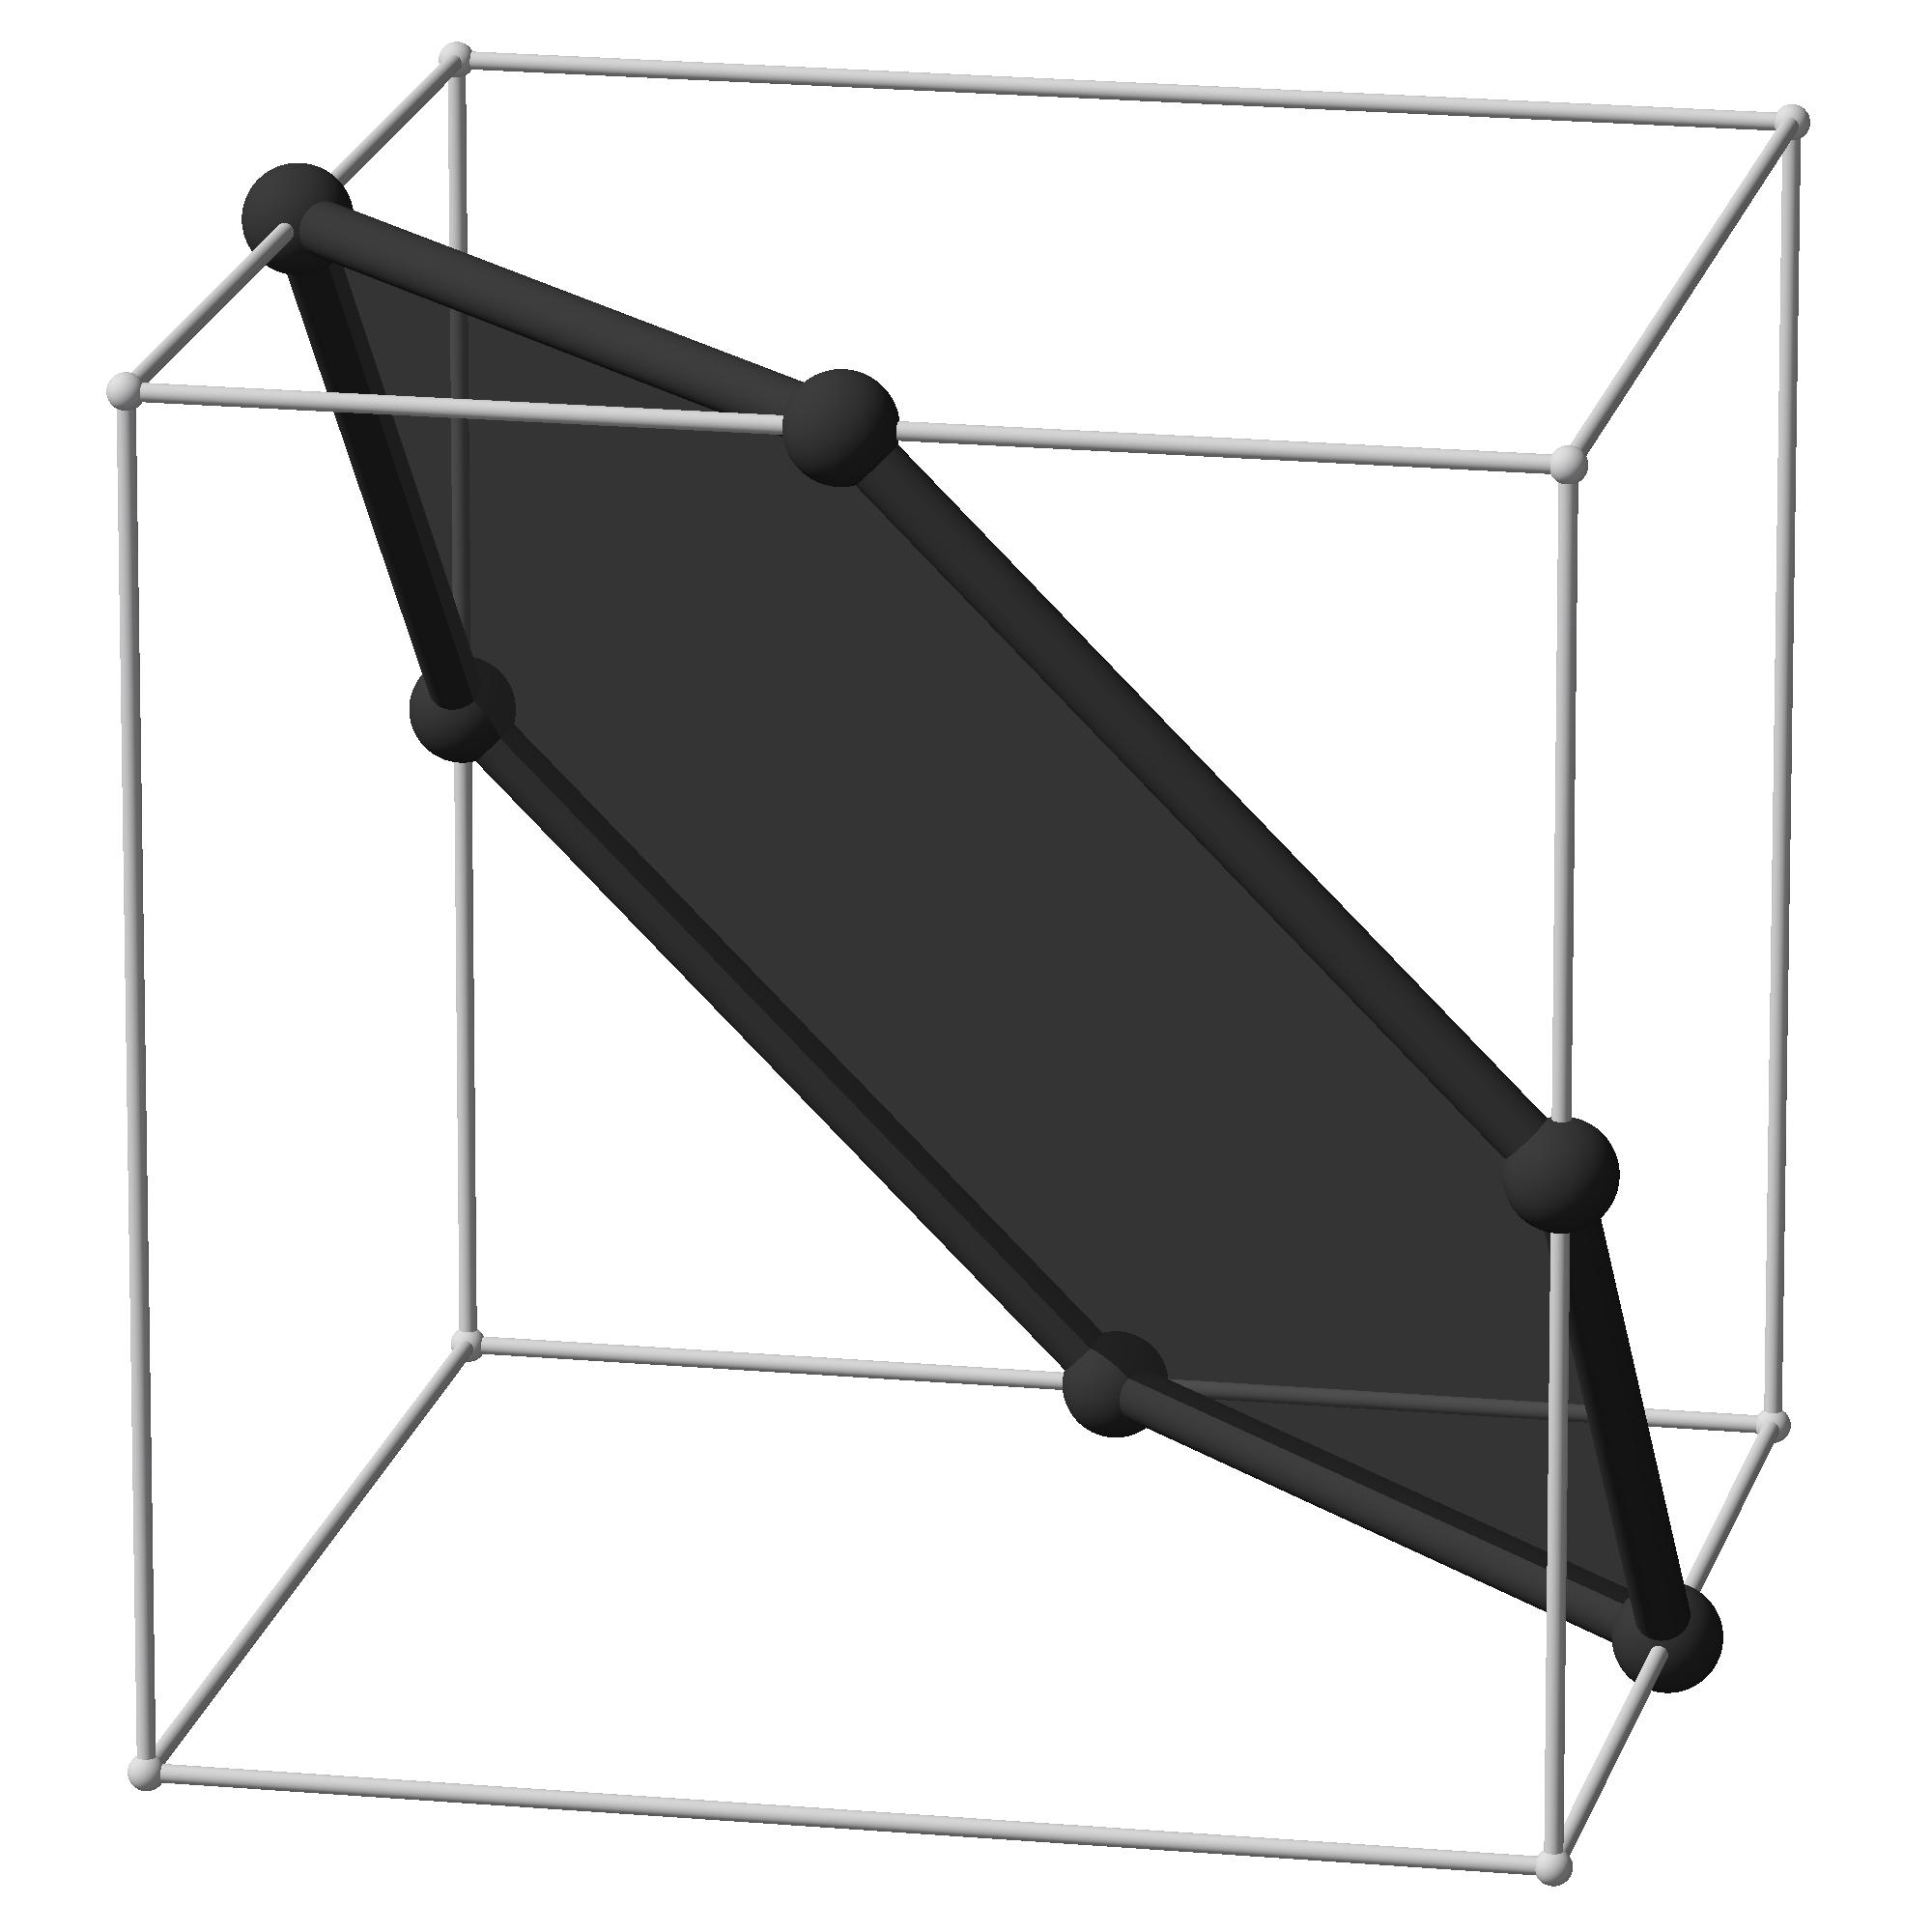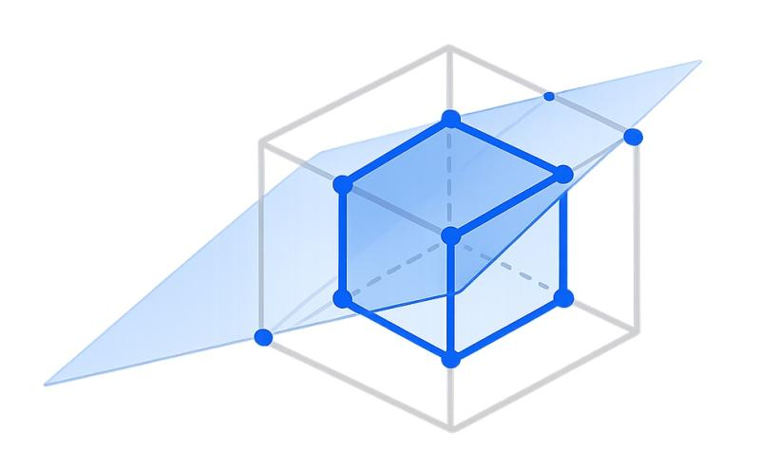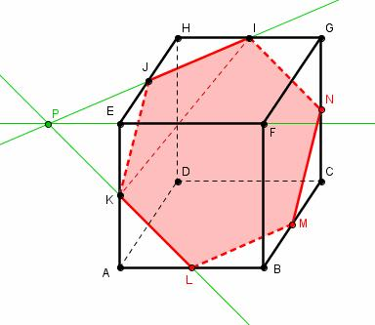
Examples:
- Cube intersected by a plane passing through all six faces.
- Other polyhedra intersected by an inclined plane that produces six boundary segments.

Circular Oblique Cross Section
# Source: AI Source: Provided by: [Data Path: Persons Table -> ID Column: 1, Name_En Column: Motasem Essam] -> From: [ChatGPT] on [7/25/2026]
A Circular Oblique Cross Section is a cross-section whose boundary forms a circle, even though the cutting plane is inclined relative to the horizontal base plane.
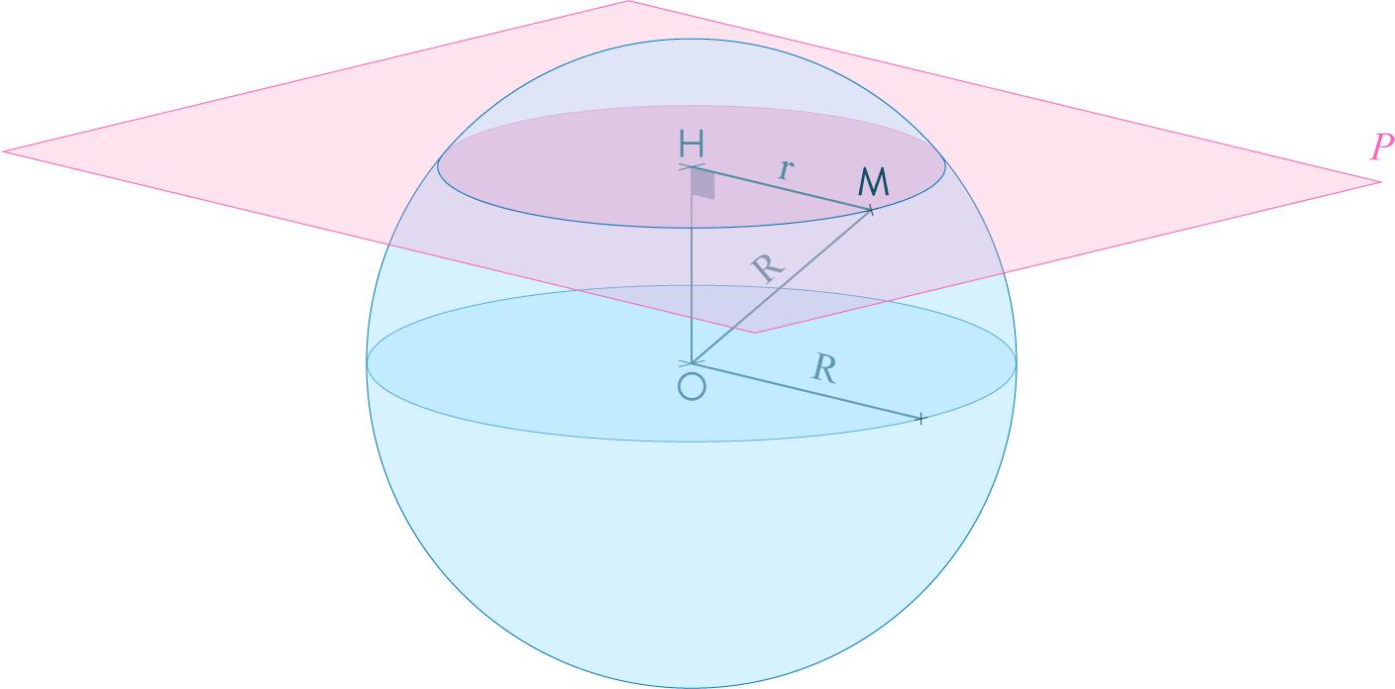
A sphere produces a circular cross-section for every plane that intersects its interior, regardless of the plane's orientation.
The circle's radius depends on the perpendicular distance between the cutting plane and the sphere's center.

Elliptical Oblique Cross Section
# Source: AI Source: Provided by: [Data Path: Persons Table -> ID Column: 1, Name_En Column: Motasem Essam] -> From: [ChatGPT] on [7/25/2026]
An Elliptical Oblique Cross Section is formed when an inclined plane intersects a solid and produces an elliptical boundary.
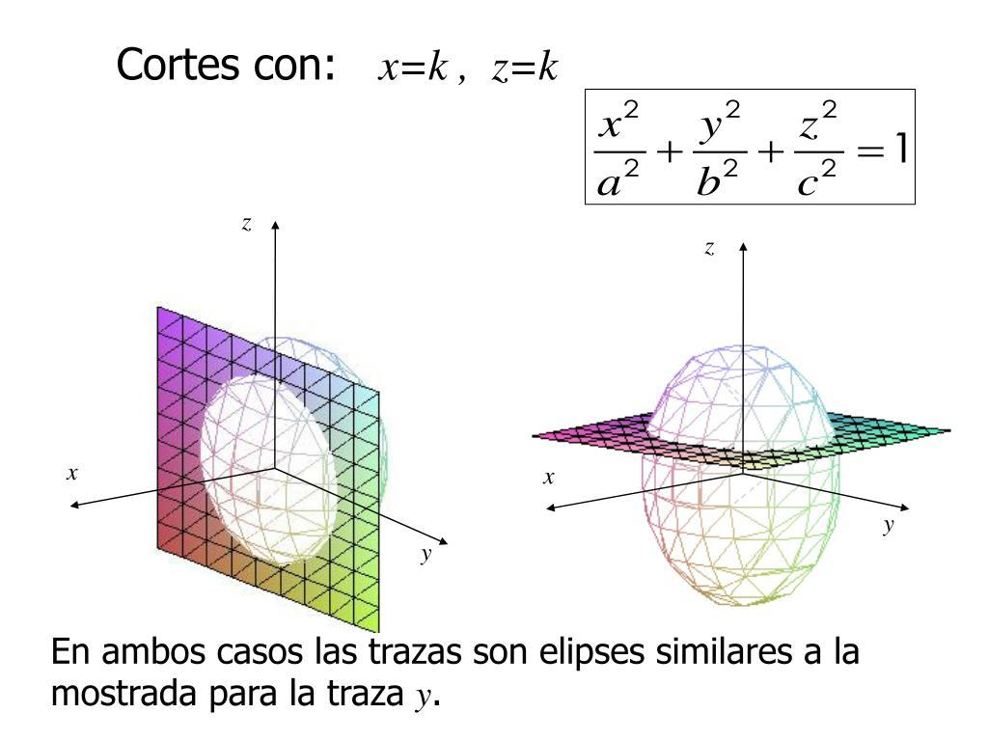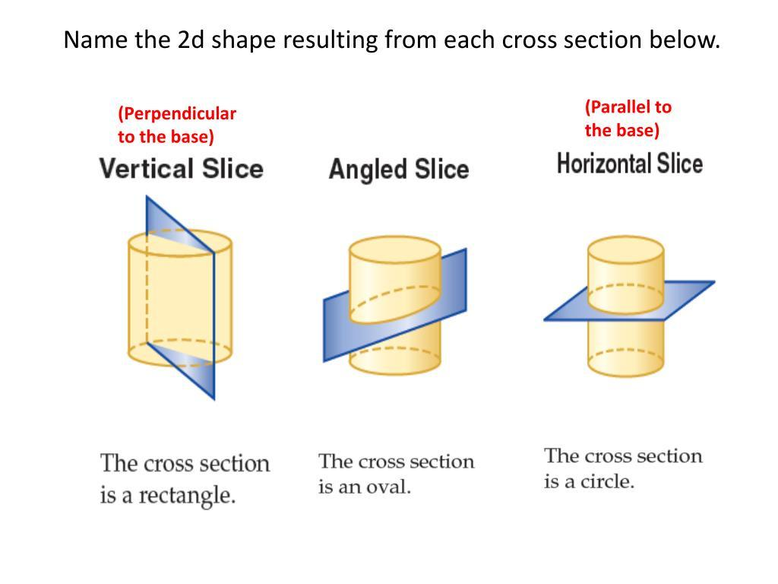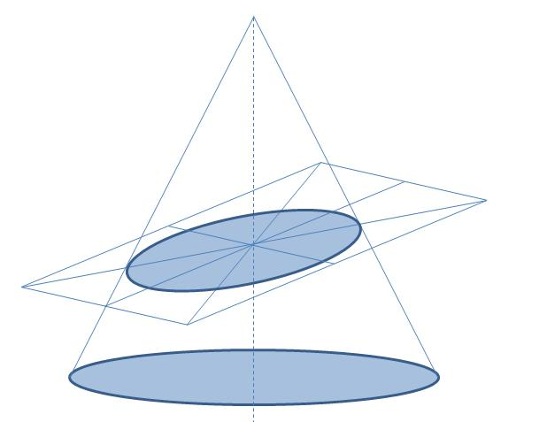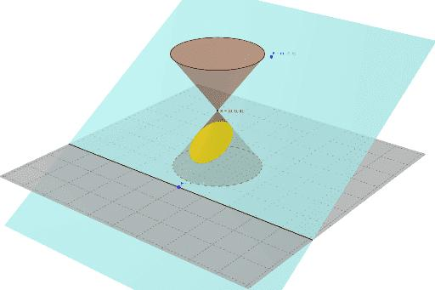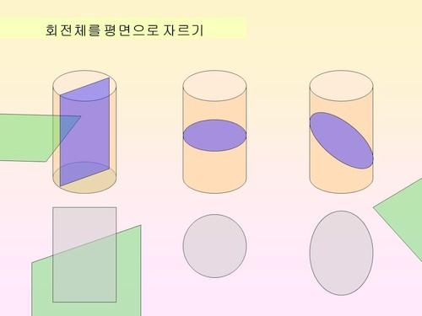
Examples:
- Right Circular Cylinder intersected by an oblique plane that is not parallel to its axis or bases.
- Right Circular Cone intersected by an inclined plane that cuts only one nappe and does not pass through its apex.
- Ellipsoid intersected by an inclined plane.
Ellipse area:
$$A=πab$$
Where:
- $a$ = semi-major axis.
- $b$ = semi-minor axis.

Curvilinear Oblique Cross Section
# Source: AI Source: Provided by: [Data Path: Persons Table -> ID Column: 1, Name_En Column: Motasem Essam] -> From: [ChatGPT] on [7/25/2026]
A Curvilinear Oblique Cross Section is a cross-section whose boundary contains curved portions that do not necessarily form a standard circle or ellipse.
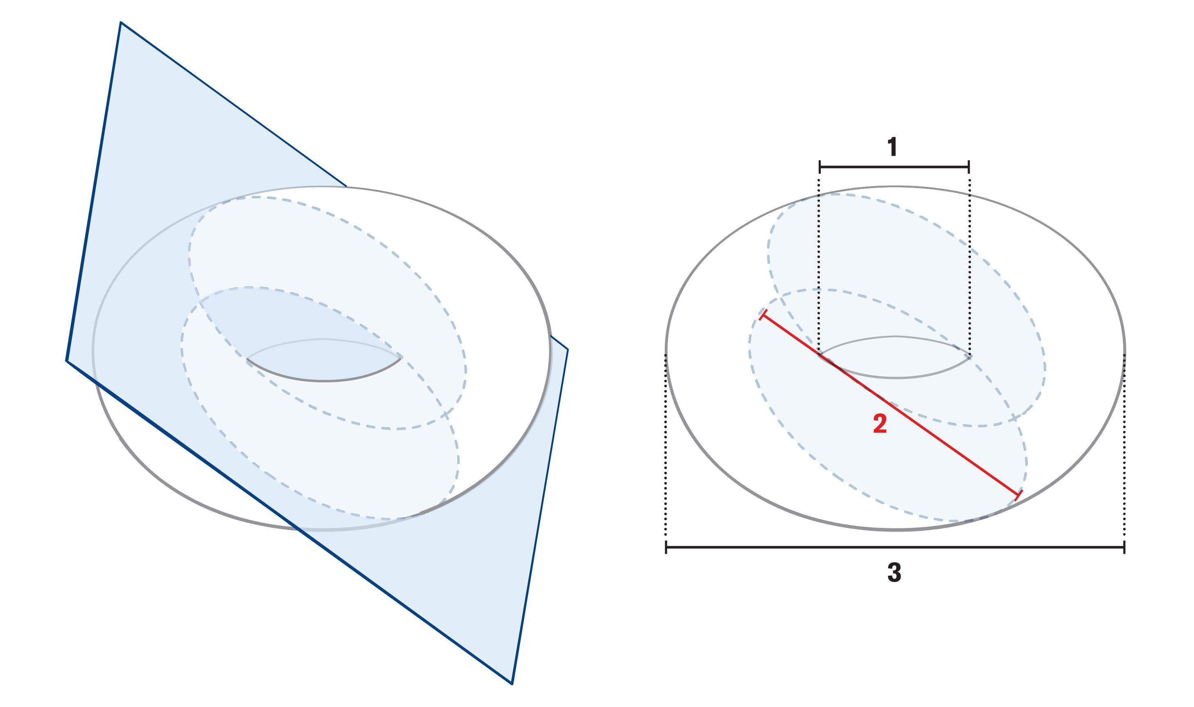
Examples:
- Torus intersected by an inclined plane.
- Complex curved solids intersected by oblique planes.
- Composite solids with curved and planar surfaces.

Oblique Cross Sections of Common Geometric Solids
# Source: AI Source: Provided by: [Data Path: Persons Table -> ID Column: 1, Name_En Column: Motasem Essam] -> From: [ChatGPT] on [7/25/2026]
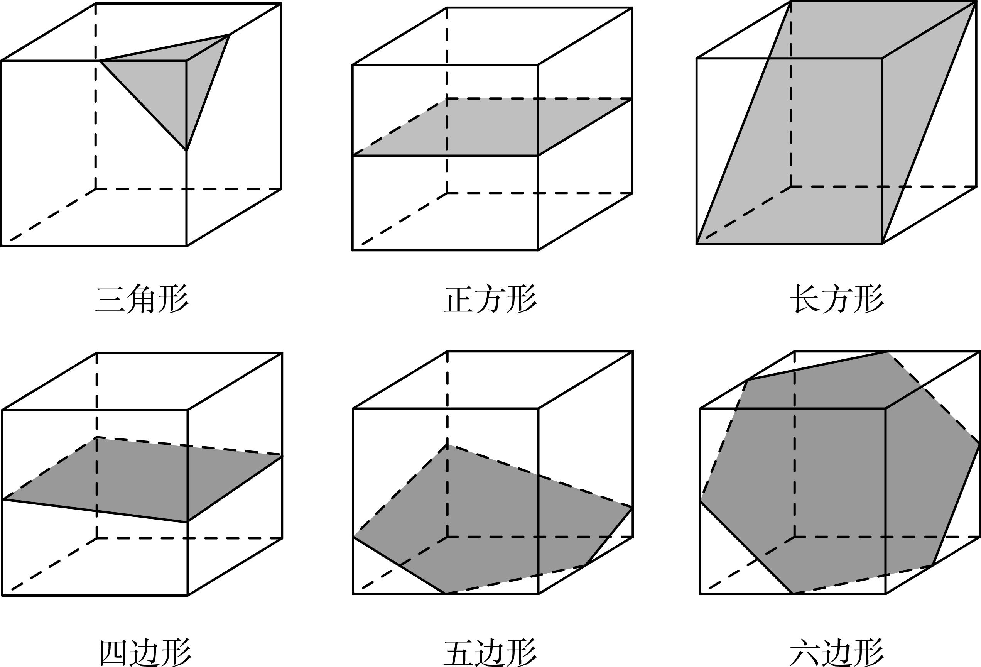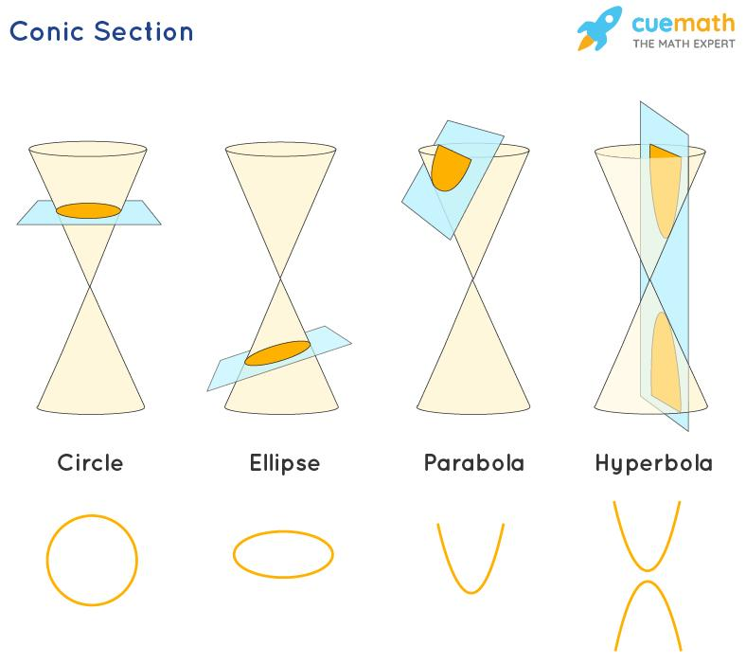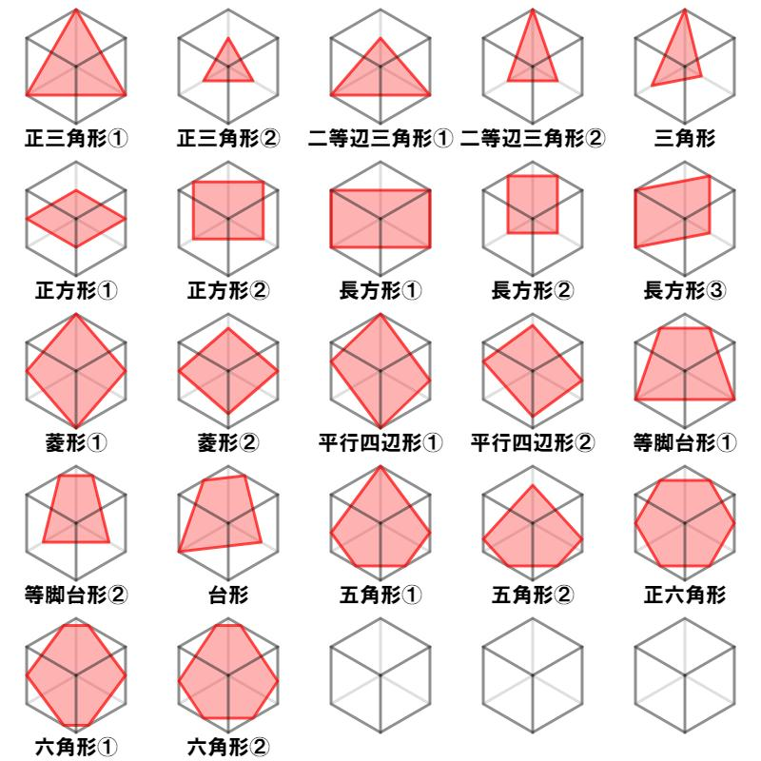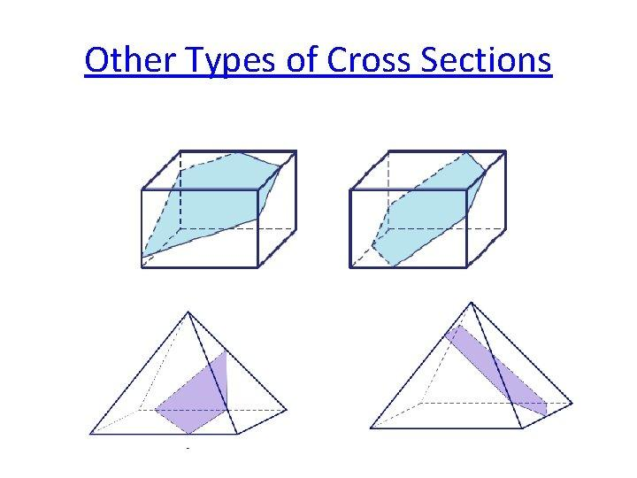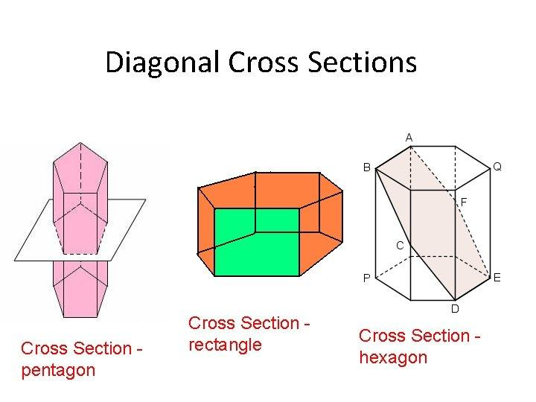
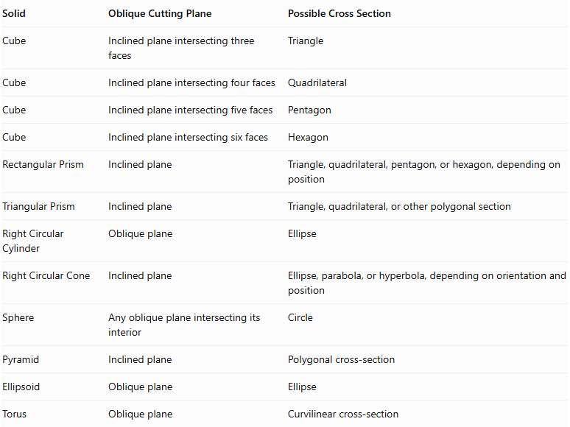
Solid | Oblique Cutting Plane | Possible Cross Section
Cube | Inclined plane intersecting three faces | Triangle
Cube | Inclined plane intersecting four faces | Quadrilateral
Cube | Inclined plane intersecting five faces | Pentagon
Cube | Inclined plane intersecting six faces | Hexagon
Rectangular Prism | Inclined plane | Triangle, quadrilateral, pentagon, or hexagon, depending on position
Triangular Prism | Inclined plane | Triangle, quadrilateral, or other polygonal section
Right Circular Cylinder | Oblique plane | Ellipse
Right Circular Cone | Inclined plane | Ellipse, parabola, or hyperbola, depending on orientation and position
Sphere | Any oblique plane intersecting its interior | Circle
Pyramid | Inclined plane | Polygonal cross-section
Ellipsoid | Oblique plane | Ellipse
Torus | Oblique plane | Curvilinear cross-section
Important: The possible polygonal sections of a polyhedron depend on how many faces the plane intersects. For curved solids, the intersection may produce conic sections or more complicated curves.

Special Case: Conic Sections from an Oblique Plane
# Source: AI Source: Provided by: [Data Path: Persons Table -> ID Column: 1, Name_En Column: Motasem Essam] -> From: [ChatGPT] on [7/25/2026]
One important application of oblique cross-sections is the generation of conic sections by intersecting a double cone with different inclined planes.
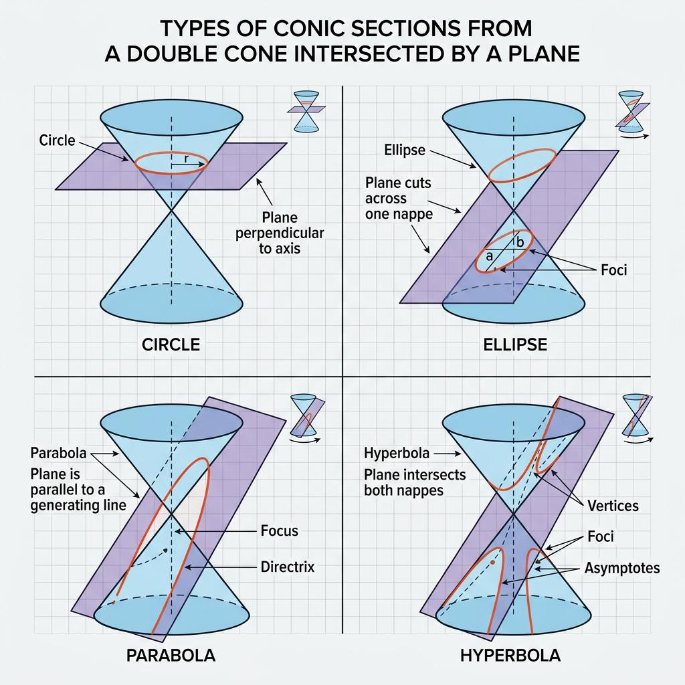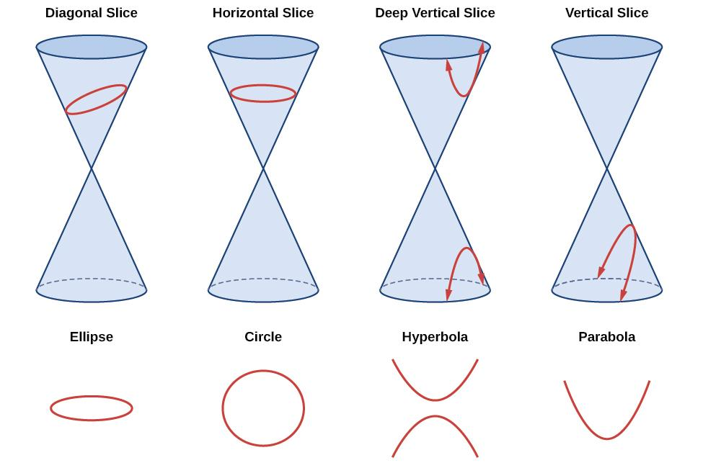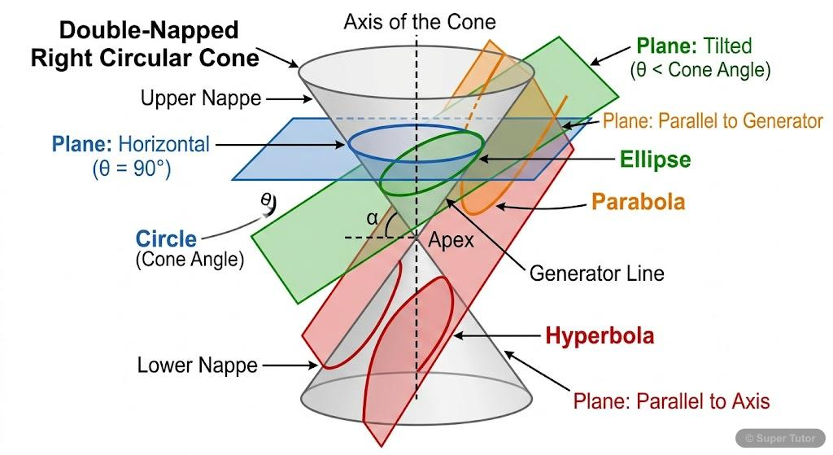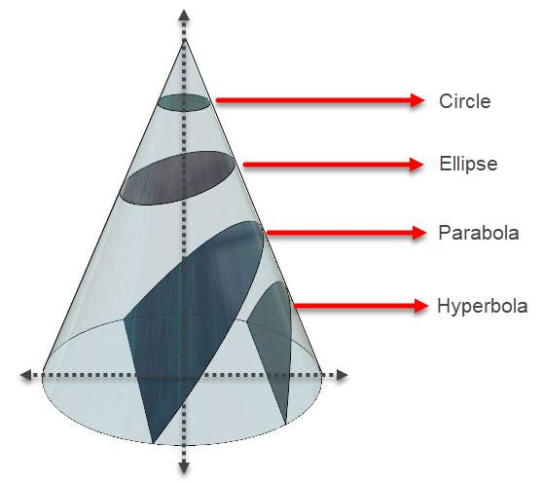

Elliptical Section
# Source: AI Source: Provided by: [Data Path: Persons Table -> ID Column: 1, Name_En Column: Motasem Essam] -> From: [ChatGPT] on [7/25/2026]
An Elliptical Section occurs when the cutting plane intersects only one nappe of the double cone and is not parallel to a generator.

Parabolic Section
# Source: AI Source: Provided by: [Data Path: Persons Table -> ID Column: 1, Name_En Column: Motasem Essam] -> From: [ChatGPT] on [7/25/2026]
A Parabolic Section occurs when the cutting plane is parallel to one of the cone's generators.

Hyperbolic Section
# Source: AI Source: Provided by: [Data Path: Persons Table -> ID Column: 1, Name_En Column: Motasem Essam] -> From: [ChatGPT] on [7/25/2026]
A Hyperbolic Section occurs when the cutting plane intersects both nappes of the double cone.

Circular Section
# Source: AI Source: Provided by: [Data Path: Persons Table -> ID Column: 1, Name_En Column: Motasem Essam] -> From: [ChatGPT] on [7/25/2026]
A Circular Section occurs when the cutting plane is perpendicular to the cone's axis.
These are the four principal conic sections. The exact conic depends on the inclination and position of the cutting plane.

Mathematical Representation

General Plane Equation
# Source: AI Source: Provided by: [Data Path: Persons Table -> ID Column: 1, Name_En Column: Motasem Essam] -> From: [ChatGPT] on [7/25/2026]
An oblique plane in three-dimensional Cartesian coordinates can be represented by:
$$\boxed{ax+by+cz+d=0}$$
Where:
- $a,b,c$ determine the plane's orientation.
- $d$ determines its position.
- $(a,b,c)$ is the normal vector of the plane.
For a plane to be oblique relative to the horizontal $xy$-plane, its normal vector must have both:
- A nonzero horizontal component.
- A nonzero vertical component.
Thus:
$$\sqrt{a^{2}+b^{2}}>0$$
$$c≠0$$

Inclination Angle
# Source: AI Source: Provided by: [Data Path: Persons Table -> ID Column: 1, Name_En Column: Motasem Essam] -> From: [ChatGPT] on [7/25/2026]
Let $α$ represent the angle between the cutting plane and the horizontal $xy$-plane.
For the plane:
$$ax+by+cz+d=0$$
The inclination angle satisfies:
$$\boxed{sinα=\frac{|c|}{\sqrt{a^{2}+b^{2}+c^{2}}}}$$
For a genuinely oblique plane:
$$0^{∘}<α<{90}^{∘}$$

Cross Section as an Intersection
# Source: AI Source: Provided by: [Data Path: Persons Table -> ID Column: 1, Name_En Column: Motasem Essam] -> From: [ChatGPT] on [7/25/2026]
If $S$ represents a solid and $P$ represents an oblique plane:
$$\boxed{C=S∩P}$$
Where:
- $C$ = oblique cross-section.
- $S$ = three-dimensional solid.
- $P$ = oblique cutting plane.

Elliptical Cross-Section Area
# Source: AI Source: Provided by: [Data Path: Persons Table -> ID Column: 1, Name_En Column: Motasem Essam] -> From: [ChatGPT] on [7/25/2026]
For an elliptical cross-section:
$$\boxed{A=πab}$$
Where:
- $a$ = semi-major axis.
- $b$ = semi-minor axis.

Oblique Cross Sections and Volume
# Source: AI Source: Provided by: [Data Path: Persons Table -> ID Column: 1, Name_En Column: Motasem Essam] -> From: [ChatGPT] on [7/25/2026]
A sequence of parallel oblique cross-sections can be used to calculate the volume of a solid.
$$\boxed{V=\int_{a}^{b}{A(t)} dt}$$
Where:
- $A(t)$ = area of the cross-section at position $t$.
- $a,b$ = limits along the direction perpendicular to the parallel cutting planes.

Mathematical Properties
# Source: AI Source: Provided by: [Data Path: Persons Table -> ID Column: 1, Name_En Column: Motasem Essam] -> From: [ChatGPT] on [7/25/2026]
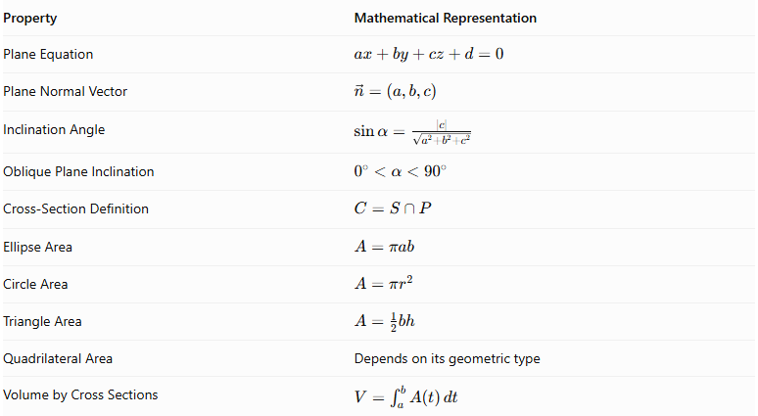
Property | Mathematical Representation
Plane Equation | $$ax+by+cz+d=0$$
Plane Normal Vector | $$vecn=(a,b,c)$$
Inclination Angle | $$(sinα=\frac{}{}$$ | $$c$$ | $$\}\sqrt{a^{2}+b^{2}+c^{2}})$$
Oblique Plane Inclination | $$0^{∘}<α<{90}^{∘}$$
Cross-Section Definition | $$C=S∩P$$
Ellipse Area | $$A=πab$$
Circle Area | $$A=πr^{2}$$
Triangle Area | $$A=\frac{1}{2}bh$$
Quadrilateral Area | Depends on its geometric type
Volume by Cross Sections | $$V=\int_{a}^{b}{A(t)} dt$$

Applications
# Source: AI Source: Provided by: [Data Path: Persons Table -> ID Column: 1, Name_En Column: Motasem Essam] -> From: [ChatGPT] on [7/25/2026]
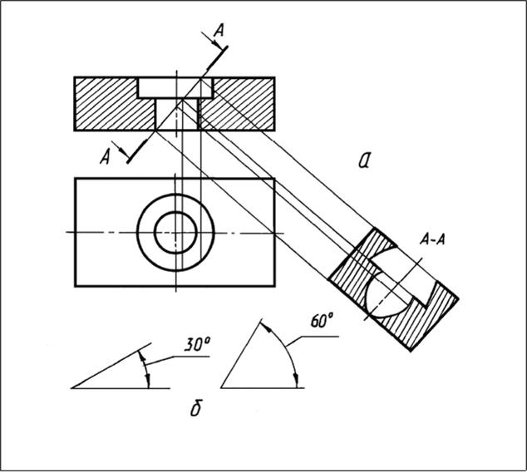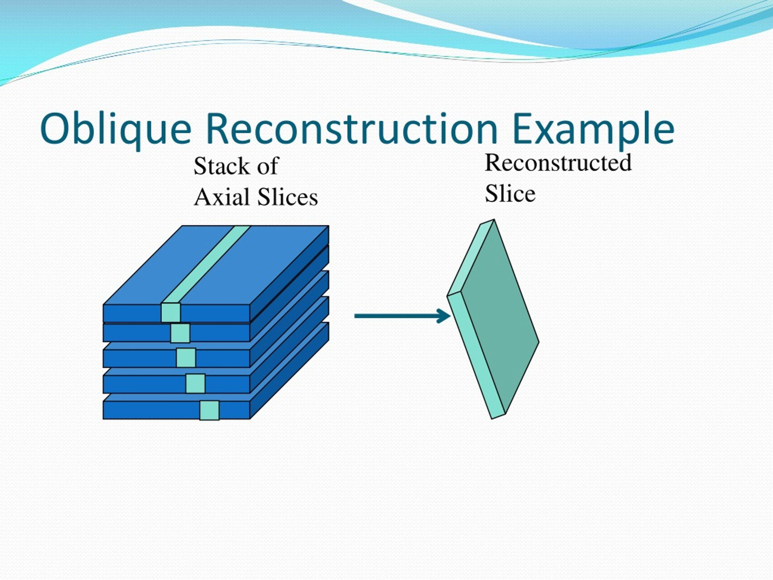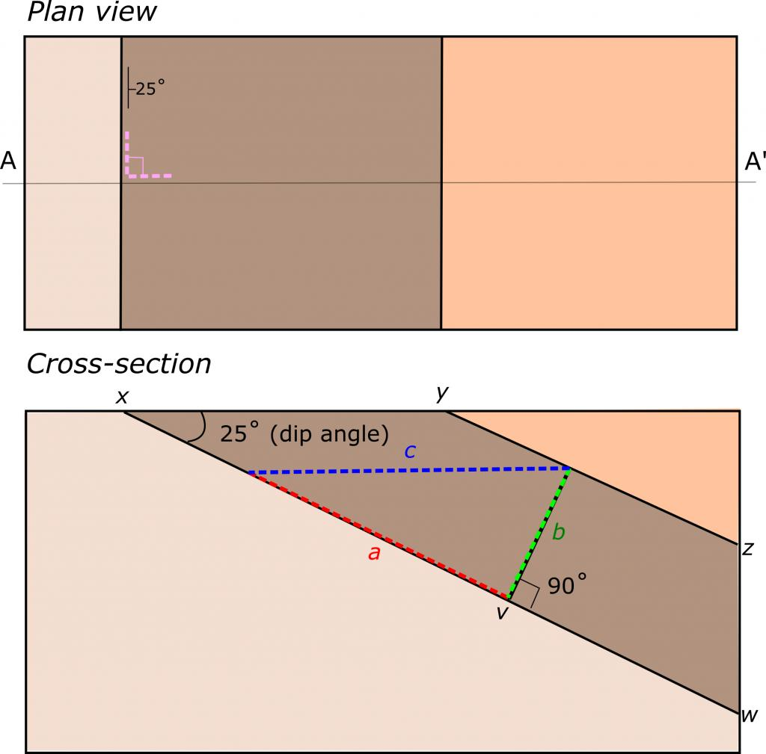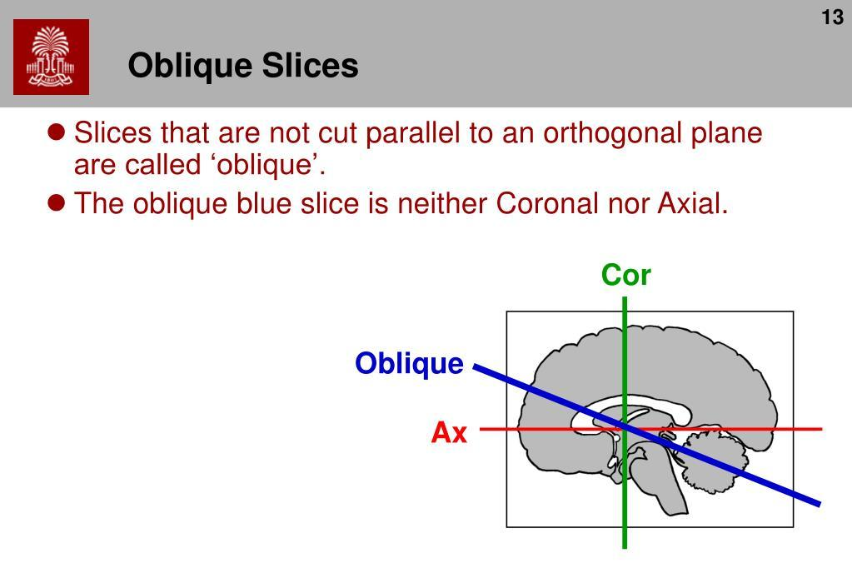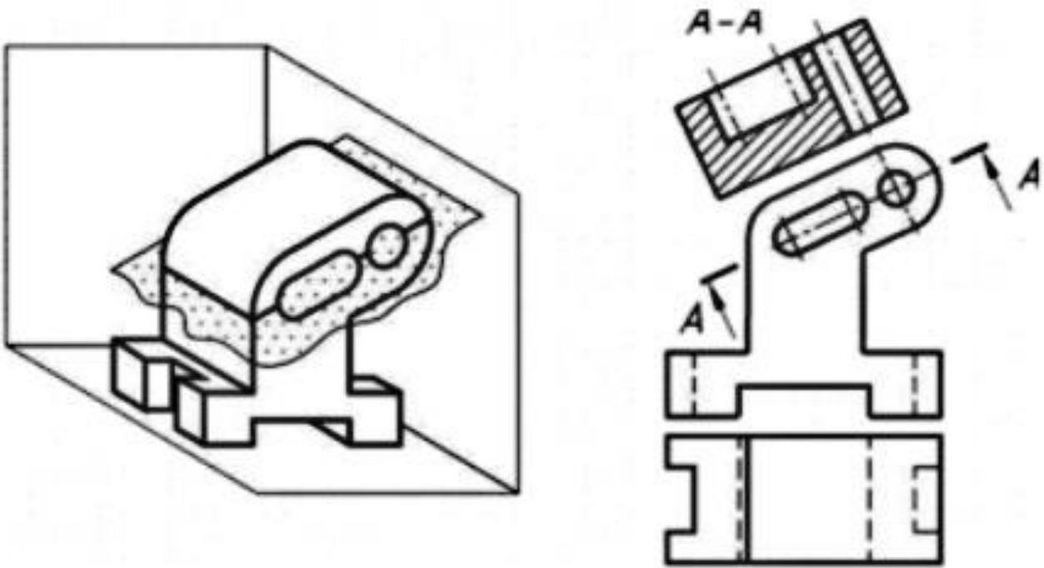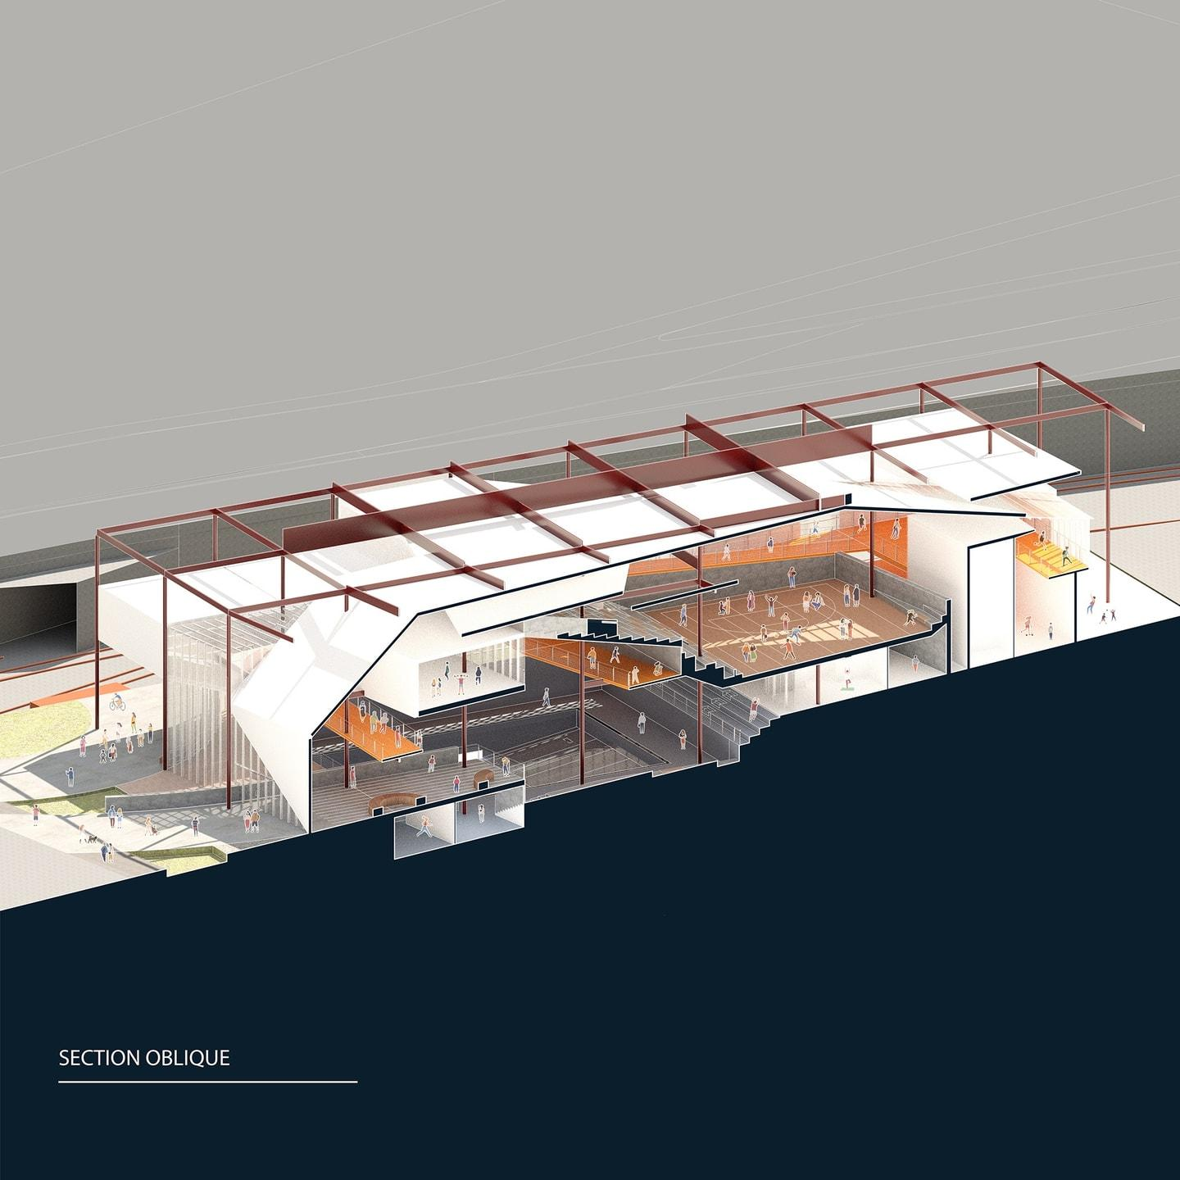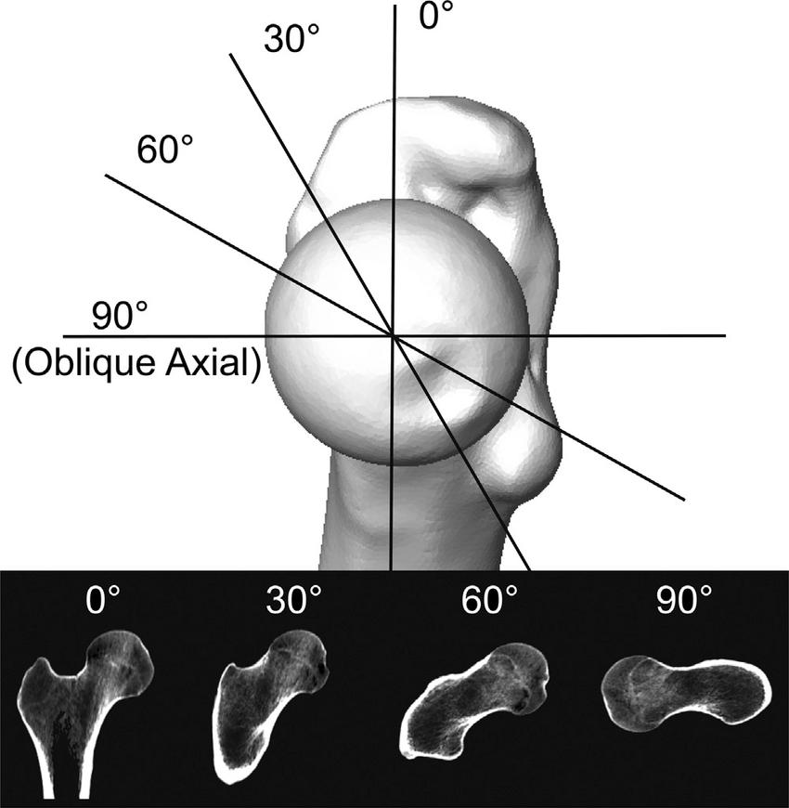
- Architecture: Examining inclined roofs, sloped structures, and diagonal building sections.
- Mechanical Engineering: Studying angled cuts through mechanical components.
- Geology: Analyzing inclined rock layers and geological formations.
- Medicine: Examining anatomical structures using oblique imaging planes.
- Manufacturing: Inspecting angled surfaces and components.
- Mathematics: Studying conic sections, spatial intersections, and solid volumes.

Comparison with Other Cross-Section Orientations
# Source: AI Source: Provided by: [Data Path: Persons Table -> ID Column: 1, Name_En Column: Motasem Essam] -> From: [ChatGPT] on [7/25/2026]
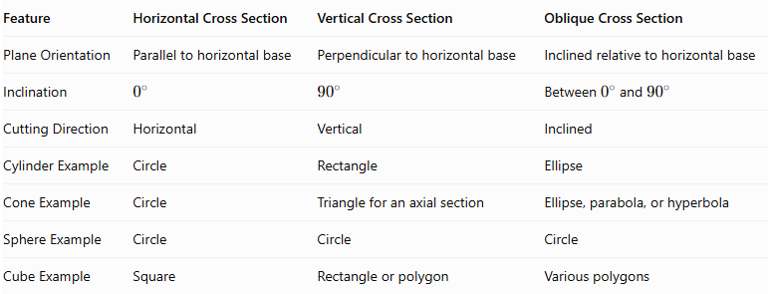
Feature | Horizontal Cross Section | Vertical Cross Section | Oblique Cross Section
Plane Orientation | Parallel to horizontal base | Perpendicular to horizontal base | Inclined relative to horizontal base
Inclination | $$0^{∘}$$ | $${90}^{∘}$$ | Between $0^{∘}$ and ${90}^{∘}$
Cutting Direction | Horizontal | Vertical | Inclined
Cylinder Example | Circle | Rectangle | Ellipse
Cone Example | Circle | Triangle for an axial section | Ellipse, parabola, or hyperbola
Sphere Example | Circle | Circle | Circle
Cube Example | Square | Rectangle or polygon | Various polygons

Main Classification
# Source: AI Source: Provided by: [Data Path: Persons Table -> ID Column: 1, Name_En Column: Motasem Essam] -> From: [ChatGPT] on [7/25/2026]
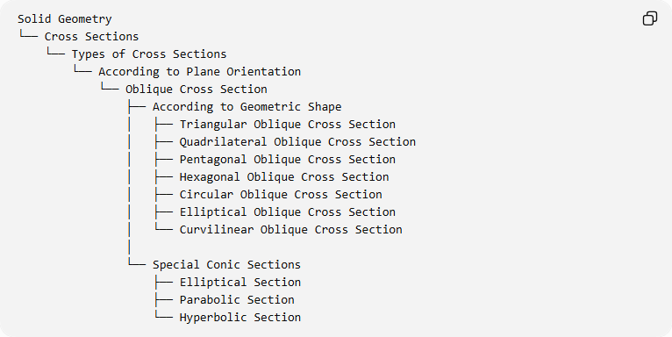
Solid Geometry
└── Cross Sections
└── Types of Cross Sections
└── According to Plane Orientation
└── Oblique Cross Section
├── According to Geometric Shape
│ ├── Triangular Oblique Cross Section
│ ├── Quadrilateral Oblique Cross Section
│ ├── Pentagonal Oblique Cross Section
│ ├── Hexagonal Oblique Cross Section
│ ├── Circular Oblique Cross Section
│ ├── Elliptical Oblique Cross Section
│ └── Curvilinear Oblique Cross Section
│
└── Special Conic Sections
├── Elliptical Section
├── Parabolic Section
└── Hyperbolic Section

Key Points
# Source: AI Source: Provided by: [Data Path: Persons Table -> ID Column: 1, Name_En Column: Motasem Essam] -> From: [ChatGPT] on [7/25/2026]
- An oblique cross-section is formed by an inclined plane intersecting a three-dimensional solid.
- The cutting plane is neither parallel nor perpendicular to the horizontal base plane.
- The resulting shape depends on the solid, cutting position, and inclination.
- Polyhedra can produce triangular, quadrilateral, pentagonal, and other polygonal sections.
- Cylinders can produce elliptical cross-sections.
- Spheres always produce circular cross-sections when intersected by a plane through their interior.
- Cones can produce elliptical, parabolic, and hyperbolic sections.
- Oblique cross-sections are useful for studying complex geometric intersections and calculating volumes.

Conclusion
# Source: AI Source: Provided by: [Data Path: Persons Table -> ID Column: 1, Name_En Column: Motasem Essam] -> From: [ChatGPT] on [7/25/2026]
An Oblique Cross Section is an important classification of cross-sections formed by intersecting a three-dimensional solid with an inclined plane. Unlike horizontal and vertical cross-sections, the cutting plane is positioned at an intermediate angle relative to the horizontal base plane.
The resulting cross-section can be polygonal, circular, elliptical, or curvilinear, depending on the solid and the cutting plane's orientation and position. Oblique cross-sections are particularly important in studying polyhedra, curved solids, conic sections, engineering structures, and three-dimensional geometric relationships.

